

**Name: Muhammad Ali Khan & Syed Fahad**

**Roll No: i210429 & i210597**

**Section: B**

**Course: Software Design and Analysis**

**Batch: BSCS 2021**

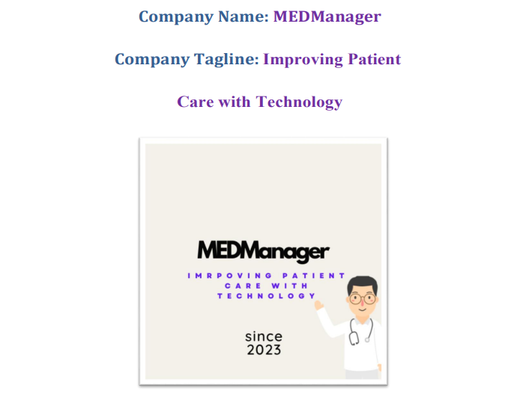

**Introduction:**

**Purpose:**

The MEDManager Online Clinical Testing System is designed with the primary purpose of revolutionizing and enhancing the healthcare experience for both patients and healthcare providers. By providing a comprehensive and user-friendly online platform, MEDManager aims to streamline the process of accessing medical testing services. Patients can conveniently book appointments for a variety of medical tests, ranging from routine blood tests to advanced imaging procedures, while having the flexibility to choose their preferred labs based on location, availability, and reputation. The system facilitates secure payment processing, ensuring a seamless financial transaction experience. Timely and secure delivery of test results is prioritized, empowering patients with quick access to crucial health information. With a focus on data security and regulatory compliance, MEDManager ensures the confidentiality and privacy of patient information. Ultimately, the system's overarching goal is to modernize healthcare service delivery, foster efficient interactions between patients and healthcare providers, and contribute to an improved and patient-centric healthcare ecosystem.

**Product Scope:**

The product scope of the MEDManager Online Clinical Testing System encompasses the entire lifecycle of clinical testing services, providing an end-to-end solution for patients, laboratories, and healthcare administrators. The system's core features include an intuitive user interface for patients to effortlessly book appointments for a wide array of medical tests, from basic screenings to specialized diagnostic procedures such as MRIs and ultrasounds. Users have the flexibility to choose from a network of accredited laboratories based on factors like location, availability, and reputation.

MEDManager facilitates secure and convenient payment processing, supporting various payment methods for a seamless financial transaction experience. The system ensures the timely and secure delivery of test results, enhancing accessibility for patients and optimizing communication between healthcare providers and individuals undergoing testing.

To uphold data security and compliance, the system adheres to strict standards, safeguarding the confidentiality and privacy of patient information. It includes features for regulatory compliance checks, actively monitoring and addressing potential vulnerabilities to ensure adherence to healthcare regulations.

In addition to patient-focused functionalities, MEDManager supports healthcare administrators and lab professionals by providing tools for effective user account management, system configuration, and compliance monitoring. The platform integrates AI assistance to improve user interactions and experiences. Furthermore, it maintains a robust feedback and analysis system to gather user reviews, identify trends, and implement enhancements for continuous improvement.

The product scope extends beyond individual interactions to include features for system administrators to monitor and manage system logs, ensuring transparency and accountability. It also supports verification processes with external regulatory authorities, such as the Ministry of Health, to validate the accuracy, reliability, and compliance of medical tests.

Overall, the MEDManager Online Clinical Testing System seeks to modernize and optimize the healthcare service landscape, fostering a user-centric approach, promoting efficiency in medical testing processes, and contributing to the overall improvement of healthcare experiences for patients and providers alike.

**Title:**

“MEDManager Online Clinical Testing System”.

**Objectives:**

The objectives of the MEDManager Online Clinical Testing System are multifaceted and aim to address key aspects of healthcare service delivery. The system's primary goals include:

**1. Efficient Appointment Booking:**

Enable patients to easily schedule appointments for a diverse range of medical tests, fostering a user-friendly and accessible booking process.

**2. Lab Selection:**

Provide patients with a choice of labs, allowing them to select facilities based on location, availability, and reputation, enhancing flexibility and convenience.

**3. Secure Payment Processing:**

Implement a robust and secure payment gateway, accommodating various payment methods, to ensure the seamless and safe processing of financial transactions.

**4. Seamless Results Delivery:**

Ensure the timely, secure, and efficient delivery of medical test results to patients, enhancing accessibility to crucial health information.

**5. Enhanced User Experience:**

Develop a user-friendly interface that simplifies the process of accessing and managing healthcare services, promoting a positive and intuitive experience for both patients and healthcare providers.

**6. Data Security and Compliance:**

Adhere to stringent data security standards and regulatory compliance, guaranteeing the confidentiality and privacy of patient information and maintaining the integrity of healthcare data.

**7. User Account Management:**

Facilitate efficient management of user accounts, including user authentication, authorization, and profile maintenance, ensuring security and personalized user experiences.

**8. Feedback and Analysis:**

Establish a robust feedback system to gather user reviews, analyze trends, and implement improvements, fostering a continuous feedback loop for system enhancement.

**9. AI Assistance:**

Integrate AI assistance to improve user interactions, provide information, and enhance the overall efficiency of the system.

**10. Compliance Monitoring:**

Conduct regular compliance checks to ensure adherence to data security and healthcare regulations, identifying and addressing potential vulnerabilities.

**11. Appointment and Payment History:**

Provide users with easy access to their appointment and payment history, promoting transparency and aiding in personal record-keeping.

**12. Ministry of Health Verification:**

Facilitate the verification of medical tests with external regulatory authorities, such as the Ministry of Health, ensuring compliance with industry standards and regulations.

**13. System Logs and Monitoring:**

Implement comprehensive system logs and monitoring tools for administrators to track system activities, troubleshoot issues, and ensure accountability.

By addressing these objectives, the MEDManager Online Clinical Testing System seeks to optimize the healthcare experience, improve efficiency in medical testing processes, and contribute to a modernized and patient-centric healthcare ecosystem.

**Problem Statement:**

In the existing healthcare environment, the process of scheduling and undergoing medical tests is often marred by inefficiencies, lack of flexibility, and a dearth of modernized solutions. Patients encounter difficulties in seamlessly booking appointments for a range of medical tests, facing limitations in lab choices and cumbersome payment processes. The absence of a standardized and user-friendly platform hampers the efficient delivery of test results and contributes to a disjointed healthcare experience. Furthermore, the prevalent issues of data security and regulatory compliance pose significant risks to the confidentiality and integrity of patient information. The need for a comprehensive online clinical testing system that addresses these challenges is evident, requiring a solution that streamlines appointment scheduling, offers lab choices, ensures secure payment processing, and enhances the overall healthcare journey while prioritizing data security and compliance. The MEDManager system seeks to bridge these gaps, providing a modernized, user-centric platform that revolutionizes the accessibility and management of clinical testing services.

**Overall Description:**

**Product Perspective:**

The MEDManager Online Clinical Testing System operates as an integrated and user-centric solution within the broader healthcare ecosystem. It interfaces with various stakeholders, including patients, healthcare providers, laboratories, and regulatory authorities, to facilitate a seamless and efficient clinical testing experience.

From a functional perspective, MEDManager acts as a central hub connecting patients with a diverse range of medical tests offered by accredited laboratories. The system accommodates the booking of appointments, secure payment processing, and timely delivery of test results, streamlining the entire process for users. It integrates AI assistance to enhance user interactions and provides a robust feedback system for continuous improvement.

The product also interfaces with healthcare administrators and lab professionals, offering tools for user account management, system configuration, and compliance monitoring. This ensures that the system aligns with regulatory standards and maintains data security.

From a technical standpoint, MEDManager interfaces with external systems for payment processing, compliance checks, and verification processes with regulatory authorities such as the Ministry of Health. It maintains comprehensive system logs for monitoring and auditing purposes, contributing to transparency and accountability.

The system's modular design and adherence to industry standards allow for scalability, adaptability, and integration with emerging technologies, ensuring that it remains at the forefront of healthcare technology. MEDManager is positioned as a transformative product that not only optimizes the patient experience but also contributes to the modernization of clinical testing services within the healthcare ecosystem.

**Product Functions:**

**1. User Authentication and Profile Management:**

Authenticate users securely during the login process.

Manage user profiles, including personal information etc.

**2. Appointment Booking:**

Enable patients to schedule appointments for various medical tests seamlessly.

Provide a user-friendly interface for selecting preferred dates, times, and test types etc.

**3. Lab Selection:**

Offer patients a choice of accredited labs based on location, availability, and reputation.

Facilitate the selection of labs during the appointment booking process.

**4. Secure Payment Processing:**

Implement a secure payment gateway to process financial transactions for appointment bookings.

Support various payment methods, ensuring a seamless and secure payment experience.

**5. Results Updating:**

Ensure timely and secure upload of medical test results to patients.

Provide a secure online platform for users to access and review their test results.

**6. Feedback and Reviews:**

Allow users to submit feedback and reviews for labs and medical tests.

Analyze feedback trends for continuous system improvement.

**7. AI Assistance:**

Provide information, guidance, and assistance to users during their interactions with the system.

**8. Compliance Monitoring:**

Can Conduct regular compliance checks to ensure adherence to data security and healthcare regulations.

Generate alerts for non-compliance issues.

**9. Appointment and Payment History:**

Maintain a history of user appointments, including details of scheduled and completed tests.

Track user payment history for transparency and record-keeping.

**10. Ministry of Health Verification:**

Facilitate the verification of medical tests with external regulatory authorities.

**11. User Account Management:**

Enable administrators to manage user accounts, including account creation, updates, and deactivation.

Implement role-based access control for different user types (patients, lab administrators, system administrators).

**List of Use Cases:**

* Login
* Register New User
* Search Medical Tests
* Check for Discounts
* View Nearest Labs
* Manage Payment
* View Payment History
* View Appointment History
* Rate and Review Lab
* Request Support
* AI Assistance
* Update Test Results
* Manage Lab Information
* Compliance Monitoring
* Monitor Feedback
* Verify the Tests by Ministry of Health
* User Account Management
* Data Security Checks

**Extended Use Cases:**

# 1- Manage Appointment

**Use Case Name:** Manage Appointment

**Scope:** MEDManager Online Clinical Testing System

**Level:** User level

**Primary Actor:** Patient

## Stakeholders and Their Interests:

* Patient: Interested in easily booking medical test appointments.
* Lab Administrator: Interested in receiving appointment requests and managing them efficiently.
* System Administrator: Interested in ensuring the system functions smoothly and securely and in data privacy and security compliance.
* Payment Facilitation: Interested in processing payments securely.

## Pre-Condition:

* The patient must be registered and logged in.
* The patient has identified the specific medical test they require.
* Labs and available appointment slots must be listed and accessible.

## Post-Conditions:

* An appointment is successfully booked.
* The patient receives a confirmation of the appointment.
* The lab administrator is notified of the new appointment.
* Payment, if required, is processed successfully.

## Main Success Scenario:

* Patient logs in to the MEDManager system.
* Patient searches for a specific medical test.
* The system displays a list of labs offering the test, along with available appointment slots.
* Patient selects a lab and an appointment slot.
* Patient confirms the selection.
* If payment is required, the system securely processes the payment.
* The system sends a confirmation email and notification to the patient.
* The lab administrator is notified of the new appointment.

## Alternate Success Scenario:

If the patient decides not to proceed with booking the appointment after selecting a lab and slot, they can cancel the process without any appointments being made.

## Special Requirements:

* Secure payment processing to comply with data security standards.
* Integration with notification services for sending email and mobile notifications.
* User-friendly interface to simplify the booking process.

## Technology and Variations:

* Continuous updates and improvements to the user interface to enhance user experience.
* Integration with emerging technologies such as AI for predicting appointment availability and optimizing scheduling.

## Frequency of Occurrence:

This use case is expected to occur frequently as patients schedule appointments regularly.

## Open Issues:

* Integration with external payment gateways and ensuring payment security.
* Handling cases where there is an unexpected system downtime during booking.
* Compliance with evolving healthcare regulations and standards.

# 2- Login

**Use Case Name:** Login

**Scope:** MEDManager Online Clinical Testing System

**Level:** User level

**Primary Actor:** Patient

## Stakeholders and Their Interests:

* User (Primary Stakeholder): Interested in accessing their account securely.
* System Administrator (Secondary Stakeholder): Interested in maintaining secure access control and in data privacy and security compliance.

## Pre-Condition:

* The user must have a registered account.

## Post-Conditions:

* The user is successfully logged in and gains access to their account.
* The user can now book appointments and perform payments etc.

## Main Success Scenario:

* The user navigates to the MEDManager login page.
* The system presents a login form with fields for username/email and password.
* The user enters their valid credentials (username/email and password).
* The system validates the credentials against the user database.
* If the credentials are valid, the system logs the user in and grants access to their account.
* The user can now perform actions based on their role within the system (e.g., book appointments, manage lab appointments, or administer the system).

## Alternate Success Scenario:

* If the user forgets their password, they can request a password reset through the "Forgot Password" functionality.
* If the entered credentials are incorrect, the system displays an error message.

## Special Requirements:

* Implement secure password storage and validation.
* Implement a password recovery mechanism.
* Lockout mechanism to protect against brute force attacks.
* Monitoring and logging of login attempts for security auditing.

## Technology and Variations:

* The system may incorporate multi-factor authentication for added security.
* Continuous updates to security measures to protect against emerging threats.

## Frequency of Occurrence:

Frequent, as users need to log in to access the system.

## Open Issues:

* Ensuring robust security measures to protect user credentials and data.
* User experience considerations for a smooth login process while maintaining security.

# 3- Register new user

**Use Case Name:** Register New User

**Scope:** MEDManager Online Clinical Testing System

**Level:** User level

**Primary Actor:** Patient

## Stakeholders and Their Interests:

* Patient: Interested in creating a new account to access the system's features.
* System Administrator: Interested in maintaining a secure and user-friendly registration process and in data privacy and security compliance.

## Pre-Condition:

* The user is not already registered in the MEDManager system.

## Post-Conditions:

* A new user account is successfully created, and the user is logged in.
* The user can now access the system's features and functionalities.

## Main Success Scenario:

* The user accesses the MEDManager registration page.
* The system presents a registration form with fields for personal information (e.g., name, email), contact details, and a password.
* The user enters their valid information, including a unique email address and a strong password.
* The system validates the provided information, ensuring that the email address is unique and that the password meets security criteria.
* If the information is valid, the system creates a new user account and logs the user in automatically.
* The user can now access the system's features and may be prompted to complete their user profile or perform other actions based on their role.

## Alternate Success Scenario:

* If the user encounters any issues during registration, they can access a "Help" or "Support" feature to receive assistance.
* The user is prompted to correct the errors and resubmit the registration form.

## Special Requirements:

* Implement secure password storage and validation.
* Ensure unique email addresses for each user.
* Enable password strength validation.
* Provide CAPTCHA or other anti-bot mechanisms to prevent automated registration attempts.

## Technology and Variations:

* Consider implementing multi-factor authentication (MFA) as an additional security layer.
* Continuously update security measures to protect against evolving threats.

## Frequency of Occurrence:

Frequent, as new users need to register to access the system.

## Open Issues:

* Maintaining data privacy and security during the registration process.
* User experience considerations for a smooth and user-friendly registration process.
* Compliance with relevant data protection and privacy regulations.

# 4- Search Medical Tests

**Use Case Name:** Search Medical Tests

**Scope:** MEDManager Online Clinical Testing System

**Level:** User level

**Primary Actor:** Patient

## Stakeholders and Their Interests:

* Patient: Interested in finding specific medical tests.
* System Administrator: Interested in ensuring efficient search functionality and in data privacy and security compliance.

## Pre-Condition:

* The user is logged into the MEDManager system.

## Post-Conditions:

* The user is presented with a list of medical tests matching their search criteria.

## Main Success Scenario:

* The user navigates to the "Search Medical Tests" feature within the MEDManager system.
* The system presents a search interface with fields for entering search criteria, such as test name or category.
* The user enters relevant search criteria, e.g., "MRI," "Blood Test," or a specific medical condition.
* The system processes the search query and retrieves a list of medical tests matching the criteria.
* The system displays the list of matching tests, including test names, descriptions, and available labs offering each test.
* The user can click on a specific test to view more details or proceed with booking an appointment.

## Alternate Success Scenario:

* If the user's initial search doesn't yield relevant results, they can refine their search criteria or use filters to narrow down the list of medical tests.
* If the user's search criteria do not match any available medical tests, the system displays a message indicating that no results were found.
* The user can choose to modify their search criteria or explore other features of the system.

## Special Requirements:

* Implement a robust search algorithm to ensure accurate and fast search results.
* Consider incorporating autocomplete or suggestions to assist users in formulating search queries.
* Ensure that the search feature complies with data privacy and security regulations.

## Technology and Variations:

* Continuously improve search functionality based on user feedback and evolving search technologies.
* Integration with external medical databases to expand the range of available medical tests.

## Frequency of Occurrence:

Frequent, as users often search for specific medical tests when booking appointments.

## Open Issues:

* Optimizing search performance for a growing database of medical tests.
* User interface enhancements to make the search process more intuitive and efficient.
* Ensuring data privacy and security during search operations.

# 5- Check for Discounts

**Use Case Name:** Check for Discounts

**Scope:** MEDManager Online Clinical Testing System

**Level:** User level

**Primary Actor:** Patient

## Stakeholders and Their Interests:

* Patient: Interested in finding and applying any available discounts on medical tests.
* System Administrator: Interested in maintaining a seamless discount management system.
* Lab Administrator: Interested in ensuring that any discounts applied are valid and processed correctly.

## Pre-Condition:

* The user is logged into the MEDManager system and the user has selected a specific medical test for booking.

## Post-Conditions:

* The user is presented with information about available discounts for the selected medical test and if applicable, the discount is applied to the test's cost.

## Main Success Scenario:

* The user selects a medical test they wish to book.
* In the booking process, the system presents an option to check for available discounts for the selected test.
* The user chooses to check for discounts.
* The system queries the database for any available discounts associated with the selected test.
* If discounts are found, the system displays information about the discounts, including the discount amount, eligibility criteria, and expiration date.
* The user can choose to apply a discount if they meet the eligibility criteria.
* If the user applies a discount, the system recalculates the cost of the medical test, taking the discount into account.
* The user can proceed with booking the test at the discounted price.

## Alternate Success Scenario:

* If no discounts are available for the selected medical test, the system informs the user that no discounts are applicable.
* If the user attempts to apply a discount for which they do not meet the eligibility criteria, the system displays an error message.
* The user can either correct the eligibility issue or proceed without the discount.

## Special Requirements:

* Implement a comprehensive discount management system to track and apply discounts accurately.
* Ensure that discount-related information is displayed clearly to the user.
* Implement secure and tamper-proof discount validation processes.

## Technology and Variations:

* Continuously update the discount management system to incorporate new discount types and rules.
* Explore the possibility of integrating with external coupon or discount services.

## Frequency of Occurrence:

Occasional, as users may choose to check for discounts when booking medical tests.

## Open Issues:

* Ensuring that discount eligibility criteria are clearly defined and verified.
* Data privacy and security considerations when handling discount-related information.
* User interface improvements to make the discount checking process user-friendly and transparent.

# 6- View Nearest Labs

**Use Case Name**: View Nearest Labs

**Scope:** MEDManager Online Clinical Testing System

**Level:** User level

**Primary Actor:** Patient

## Stakeholders and Their Interests:

* + Patient: Interested in finding and selecting the nearest laboratories for medical tests.
  + System Administrator: Interested in ensuring an efficient and accurate lab location retrieval system.
  + Lab Administrators: Interested in patients being able to find and select their labs conveniently.

## Pre-Condition:

* + The user is logged into the MEDManager system and the user has selected a specific medical test for booking or is searching for labs without specifying a test.

## Post-Conditions:

* + The user is presented with a list of the nearest labs that offer the selected medical test or a list of labs if no test is specified.

## Main Success Scenario:

* + The user navigates to the "View Nearest Labs" feature within the MEDManager system.
  + The system presents a search interface with fields for entering location information or a specific medical test.
  + The user enters relevant search criteria, such as location or a medical test name.
  + The system processes the search query and retrieves a list of labs matching the criteria.
  + The system displays the list of labs, sorted by proximity to the user's specified location, or based on relevance if a test is specified.
  + Each lab entry includes details such as the lab's name, address, contact information, available medical tests, and user ratings.
  + The user can select a lab to view more details or proceed with booking an appointment.

## Alternate Success Scenario:

* + If the user's initial search doesn't yield relevant results, they can refine their search criteria or use filters to narrow down the list of labs.
  + If the user's search criteria do not match any available labs, the system displays a message indicating that no results were found.
  + The user can choose to modify their search criteria or explore other features of the system.

## Special Requirements:

* + Implement a robust location-based search algorithm to ensure accurate and fast results.
  + Provide users with the option to use their current location for proximity-based searches.

## Technology and Variations:

* + Continuously improve location-based search functionality based on user feedback and evolving geolocation technologies.
  + Integration with external location data providers for up-to-date lab location information.

## Frequency of Occurrence:

Frequent, as users often search for labs when booking appointments or looking for nearby healthcare facilities.

## Open Issues:

* + Optimizing search performance for a growing database of labs and complex location-based queries.
  + User interface enhancements to make the lab search process more intuitive and efficient.
  + Ensuring data privacy and security when handling location data.

# Manage Payment

**Use Case Name:** Manage Payment

**Scope:** MEDManager Online Clinical Testing System

**Level:** User level

**Primary Actor:** Patient, Lab Administrator

## Stakeholders and Their Interests:

* Patient: Interested in making secure payments for medical tests and managing their payment methods.
* Lab Administrator: Interested in receiving payments from patients and verifying their accuracy.
* System Administrator: Interested in maintaining a secure and efficient payment processing system.
* Payment Facilitation: Interested in processing payments securely.

## Pre-Condition:

* The user is logged into the MEDManager system and the user has initiated a payment or is managing their payment methods.

## Post-Conditions:

* The payment is successfully processed, and a payment confirmation is generated.
* The user can review and manage their payment methods.

## Main Success Scenario:

* The user navigates to the "Manage Payment" feature within the MEDManager system.
* The system presents options for the user to manage their payment methods or make a payment.
* If the user chooses to manage payment methods:
* The system displays the user's existing payment methods (e.g., credit cards, bank accounts).
* The user can add, edit, or delete payment methods as needed.
* If the user chooses to make a payment:
* The system presents a payment form with fields for selecting a payment method and entering payment details.
* The user selects a payment method from their saved options or enters new payment information.
* The system securely processes the payment through the payment gateway.
* The system generates a payment confirmation and provides a receipt to the user.
* If payment is for a specific appointment or test, the system links the payment to that appointment or test.

## Alternate Success Scenario:

* If the user decides not to proceed with payment or payment method management, they can cancel the process without making changes.
* If there is an issue with processing the payment (e.g., insufficient funds, declined card), the system displays an error message.
* The user can choose to retry the payment with a different method or address the payment issue.

## Special Requirements:

* Implement secure payment processing through a trusted payment gateway.
* Provide a user-friendly interface for managing payment methods.
* Ensure that payment information is stored securely and complies with data privacy and security regulations.

## Technology and Variations:

* Continuously update payment processing technologies to stay current with security standards.
* Consider integrating with emerging payment methods or services to offer user convenience.

## Frequency of Occurrence:

Frequent, as users regularly make payments for medical tests and may need to manage their payment methods.

## Open Issues:

* Ensuring the security and privacy of payment data throughout the payment process.
* Handling and resolving payment disputes or issues promptly.
* Compliance with relevant data protection and payment processing regulations.

# 8- View Payment History

**Use Case Name:** View Payment History

**Scope:** MEDManager Online Clinical Testing System

**Level:** User level

**Primary Actor:** Patient, Lab Administrator

## Stakeholders and Their Interests:

* Patient: Interested in reviewing their payment history for medical tests and appointments.
* Lab Administrator: Interested in accessing payment records related to their laboratory services.
* System Administrator: Interested in maintaining an efficient and secure payment history retrieval system.

## Pre-Condition:

* The user is logged into the MEDManager system.

## Post-Conditions:

* The user is presented with a list of their payment history records.

## Main Success Scenario:

* The user navigates to the "View Payment History" feature within the MEDManager system.
* The system retrieves and displays a list of payment history records associated with the user's account.
* Each payment history record includes details such as:
* Payment date and time
* Payment amount
* Payment method used
* Purpose of payment (e.g., appointment booking, specific medical test)
* Status of the payment (e.g., completed, pending)
* The user can filter and sort the payment history based on various criteria, such as date, payment amount, or purpose.
* The user can click on a specific payment record to view additional details.
* If applicable, the user can print or download payment receipts for their records.

## Alternate Success Scenario:

* If the user chooses not to view their payment history, they can exit the feature without viewing any payment records.
* If the user has no payment history records associated with their account, the system displays a message indicating that no payment history is available.
* The user can choose to return to other features or continue using the system.

## Special Requirements:

* Implement a secure and efficient payment history retrieval system.
* Ensure that payment history records comply with data privacy and security regulations.
* Enable the user to filter and sort payment history records for ease of access.

## Technology and Variations:

* Continuously update the payment history retrieval system to enhance search and sorting capabilities.
* Consider integrating with document management systems for easy access to payment receipts.

Frequency of Occurrence:

Occasional, as users may check their payment history periodically or as needed.

## Open Issues:

* Ensuring the security and privacy of payment history data throughout retrieval.
* Handling and resolving any discrepancies or issues related to payment history records.
* Compliance with relevant data protection and payment processing regulations.

# 9- View Appointment History

**Use Case Name:** View Appointment History

**Scope:** MEDManager Online Clinical Testing System

**Level:** User level

**Primary Actor:** Patient

## Stakeholders and Their Interests:

* Patient: Interested in reviewing their past and upcoming appointments for medical tests.
* System Administrator: Interested in maintaining an efficient and secure appointment history retrieval system.
* Regulatory Authority: Interested in data privacy and security compliance.

## Pre-Condition:

* The user is logged into the MEDManager system.

## Post-Conditions:

* The user is presented with a list of their appointment history records.

## Main Success Scenario:

* The user navigates to the "View Appointment History" feature within the MEDManager system.
* The system retrieves and displays a list of appointment history records associated with the user's account.
* Each appointment history record includes details such as:
* Appointment date and time
* Medical test or purpose of the appointment
* Lab or healthcare provider associated with the appointment
* Status of the appointment (e.g., completed, upcoming)
* The user can filter and sort the appointment history based on various criteria, such as date, test type, or lab.
* The user can click on a specific appointment record to view additional details, including test results if available.
* If applicable, the user can print or download appointment summaries or results for their records.

## Alternate Success Scenario:

* If the user chooses not to view their appointment history, they can exit the feature without viewing any appointment records.
* If the user has no appointment history records associated with their account, the system displays a message indicating that no appointment history is available.
* The user can choose to return to other features or continue using the system.

## Special Requirements:

* Implement a secure and efficient appointment history retrieval system.
* Ensure that appointment history records comply with data privacy and security regulations.
* Enable the user to filter and sort appointment history records for ease of access.

## Technology and Variations:

* Continuously update the appointment history retrieval system to enhance search and sorting capabilities.
* Integration with external systems or databases to fetch historical appointment data if necessary.

## Frequency of Occurrence:

Occasional, as users may check their appointment history when needed or for reference.

## Open Issues:

* Ensuring the security and privacy of appointment history data throughout retrieval.
* Handling and resolving any discrepancies or issues related to appointment history records.
* Compliance with relevant data protection regulations, especially regarding the storage and accessibility of medical records.

# 10- Rate and Review Lab

**Use Case Name:** Rate and Review Lab

**Scope**: MEDManager Online Clinical Testing System

**Level:** User level

**Primary Actor:** Patient

## Stakeholders and Their Interests:

* Patient: Interested in providing feedback and ratings for labs they have used for medical tests.
* Lab Administrator: Interested in receiving and responding to patient feedback to improve services.
* System Administrator: Interested in maintaining an efficient and secure feedback and rating system.

## Pre-Condition:

* The user is logged into the MEDManager system and the user has completed a medical test at a specific lab.

## Post-Conditions:

* The user's rating and review are recorded in the system and may be viewable by other users.

## Main Success Scenario:

* After completing a medical test at a lab, the user navigates to the "Rate and Review Lab" feature within the MEDManager system.
* The system presents a list of labs the user has visited recently.
* The user selects the lab they want to rate and review.
* The system displays a rating interface that allows the user to assign a numerical rating (e.g., out of 5 stars) for the lab's services.
* The user can also provide a written review, detailing their experience with the lab, including aspects like cleanliness, staff behavior, and overall satisfaction.
* The user submits the rating and review.
* The system records the user's feedback, assigns the rating to the lab, and associates the review with the specific lab visit.

## Alternate Success Scenario:

* If the user chooses not to rate and review a lab, they can exit the feature without providing feedback.
* If the user wants to edit or delete a previously submitted review, they can access their own review history.
* The system allows the user to make changes or delete their review, provided it meets certain criteria and is within a reasonable timeframe.

## Special Requirements:

* Implement a secure and efficient rating and review system.
* Ensure that user ratings and reviews are displayed accurately and fairly.
* Enable the lab administrator to view and respond to reviews if desired.

## Technology and Variations:

* Continuously update the rating and review system to enhance user experience and transparency.
* Consider implementing features like anonymity options for reviewers if privacy is a concern.

## Frequency of Occurrence:

Occasional, as users may choose to rate and review labs after completing medical tests.

## Open Issues:

* Ensuring the security and privacy of user feedback and reviews.
* Handling and moderating reviews to prevent misuse or inappropriate content.
* Compliance with relevant data protection regulations regarding user-generated content and privacy.

# 11- Request Support

**Use Case Name:** Request Support

**Scope:** MEDManager Online Clinical Testing System

**Level:** User level

**Primary Actor:** Patient, Lab Administrator

## Stakeholders and Their Interests:

* User: Interested in obtaining assistance or support for issues related to the MEDManager system.
* System Administrator: Interested in efficiently managing and responding to support requests.
* Lab Administrator: Interested in providing support to users and resolving issues related to lab services.

## Pre-Condition:

* The user is logged into the MEDManager system.

## Post-Conditions:

* The user's support request is recorded in the system, and a response may be provided.

## Main Success Scenario:

* The user encounters an issue or requires assistance while using the MEDManager system.
* The user navigates to the "Request Support" feature within the system.
* The system presents a form or interface for the user to describe their issue or request.
* The user provides details about the problem, including a clear description of the issue, any error messages received, and relevant context.
* The user may include attachments or screenshots to further clarify the issue.
* The user submits the support request.
* The system records the user's request and assigns it a unique identifier for tracking.
* The system may automatically categorize the support request based on keywords or content.
* If the user is a lab administrator, the request may be routed to the appropriate support team within the organization.
* Support personnel review and respond to the support request within a reasonable timeframe.
* The system notifies the user of the response, which may include guidance on resolving the issue or additional information.

## Alternate Success Scenario:

* If the user's support request does not require immediate assistance, they can choose not to submit it and continue using the system.
* If the user is not satisfied with the initial support response or if the issue remains unresolved, they can request a follow-up or escalation.
* The system records the follow-up or escalation request and routes it to the appropriate support personnel or team for further assistance.

## Special Requirements:

* Implement a secure and efficient support request management system.
* Ensure that support requests are tracked and responded to within defined service level agreements.
* Enable lab administrators to provide support to users effectively.

## Technology and Variations:

* Continuously update the support request system to improve response times and user satisfaction.
* Implement mechanisms for tracking the status and progress of support requests.

## Frequency of Occurrence:

Occasional, as users may request support when they encounter issues or have questions.

## Open Issues:

* Ensuring the security and privacy of user support requests and related data.
* Establishing clear procedures for handling and escalating support requests.
* Compliance with relevant data protection regulations, especially regarding user-generated support requests and privacy.

# 12- AI- Assistance

**Use Case Name:** AI Assistance

**Scope:** MEDManager Online Clinical Testing System

**Level:** User level

**Primary Actor:** Patient, Lab Administrator

## Stakeholders and Their Interests:

* User: Interested in utilizing AI-powered assistance to enhance their experience with the MEDManager system.
* System Administrator: Interested in maintaining and improving the AI assistance functionality.
* Lab Administrator: Interested in providing and receiving AI-driven support and guidance.

## Pre-Condition:

* The user is logged into the MEDManager system.

## Post-Conditions:

* The user's AI interaction is recorded, and any actions or responses provided by the AI are executed or displayed.

## Main Success Scenario:

* The user initiates AI assistance within the MEDManager system, typically through a chat interface or voice command.
* The system's AI component greets the user and asks how it can assist them.
* The user provides a natural language or specific query or request, such as "Schedule an MRI appointment for next week" or "Can you explain my recent blood test results?"
* The AI component processes the user's request using natural language understanding and AI algorithms.
* If the user's request involves sensitive or personal information, the AI ensures that the response is compliant with data privacy regulations.
* The AI may offer follow-up questions or suggestions to clarify the user's intent or provide additional assistance.
* The user interacts with the AI as needed to accomplish their task or obtain information.

## Alternate Success Scenario:

* If the AI misunderstands the user's request or provides an incorrect response, the user can clarify or rephrase their question.
* The user requests support from the system itself in case of dissatisfaction.

## Special Requirements:

* Implement a robust natural language processing (NLP) system to understand and generate human-like responses.
* Ensure that the AI component complies with data privacy and security regulations, especially when handling sensitive medical information.
* Continuously train and update the AI model to improve its accuracy and ability to assist users.

## Technology and Variations:

* Continuous improvement and updates to the AI model based on user feedback and advancements in AI technology.
* Integration with external knowledge bases or databases to provide accurate and up-to-date information.

## Frequency of Occurrence:

Frequent, as users may seek AI assistance for a variety of tasks and inquiries while using the MEDManager system.

## Open Issues:

* Ensuring that the AI component is able to handle a wide range of user queries and requests effectively.
* Addressing any ethical considerations related to AI, such as transparency and bias.
* Complying with evolving data privacy and security regulations in the healthcare sector.

# 13- Update Test Results

**Use Case Name:** Update Test Results

**Scope:** MEDManager Online Clinical Testing System

**Level:** User level

**Primary Actor:** Lab Administrator

## Stakeholders and Their Interests:

* Lab Administrator: Interested in overseeing and managing the test result updating process and in accurately and securely updating test results for patients.
* Patient: Interested in accessing accurate and up-to-date test results through the system.
* System Administrator: Interested in ensuring data privacy, security, and system efficiency.

## Pre-Condition:

* The lab technician or lab administrator is logged into the MEDManager system.
* The lab technician has access to test results to update.
* The patient's test for which results are to be updated has been conducted.

## Post-Conditions:

* The test results are updated in the system and made available for the patient to access.
* The patient in case of any query can access the Support of the lab administrator or AI.

## Main Success Scenario:

* The lab administrator navigates to the "Update Test Results" feature within the MEDManager system.
* The system presents a list of pending test results that need to be updated.
* The lab administrator selects a specific test result to update.
* The system provides a user-friendly interface for entering or uploading the updated test result data, which may include numerical values, textual comments, or attachments.
* The lab technician ensures the accuracy and completeness of the updated test results.
* The lab technician submits the updated test result.
* The system records the updated test result in the patient's record, associating it with the specific test conducted and the patient's profile.
* The system may automatically notify the patient that their test results have been updated and are now available for review.

## Alternate Success Scenario:

* If there are no pending test results to update or the lab technician chooses not to update a specific result, they can exit the feature without making updates.
* If there is an error in updating the test result (e.g., data entry mistake), the system provides an error message.
* The lab technician can review and correct the error before resubmitting the update.

## Special Requirements:

* Implement secure authentication and authorization mechanisms to ensure that only authorized personnel can update test results.
* Ensure that updated test results are accurately associated with the correct patient and test.
* Comply with data privacy and security regulations, especially when handling sensitive medical information.

## Technology and Variations:

* Continuously improve the user interface for test result updating to enhance efficiency and accuracy.
* Implement data validation checks to prevent incorrect or incomplete updates.

## Frequency of Occurrence:

Frequent, as lab technicians regularly update test results after conducting medical tests.

## Open Issues:

* Ensuring the security and privacy of test result data throughout the updating process.
* Handling and resolving any discrepancies or issues related to test result updates.
* Compliance with relevant data protection regulations, especially regarding the storage and accessibility of medical records.

# 14- Manage lab information

**Use Case Name:** Manage Lab Information

**Scope:** MEDManager Online Clinical Testing System

**Level:** User level

**Primary Actor:** Lab Administrator

## Stakeholders and Their Interests:

* Lab Administrator: Interested in maintaining and updating lab information to ensure accuracy and relevance.
* System Administrator: Interested in overseeing and managing the lab information management functionality.

## Pre-Condition:

* The lab administrator is logged into the MEDManager system.
* The lab administrator has the necessary permissions to manage lab information.

## Post-Conditions:

* The lab information is updated in the system and made available to users and patients.

## Main Success Scenario:

* The lab administrator navigates to the "Manage Lab Information" feature within the MEDManager system.
* The system presents a dashboard or interface that displays various aspects of lab information that can be managed, such as lab details, services offered, location, operating hours, and contact information.
* The lab administrator selects a specific aspect of lab information to update.
* The system provides a user-friendly form or interface for entering or modifying the lab information.
* The lab administrator ensures the accuracy and completeness of the updated information.
* The lab administrator submits the updated lab information.
* The system records the updated lab information in the system's database, ensuring that it is accurate and up-to-date.
* The updated lab information is made available for users and patients to view when accessing the lab's details.

## Alternate Success Scenario:

* If there are no updates required or the lab administrator chooses not to make updates, they can exit the feature without making changes.
* If there is an error in updating the lab information (e.g., data entry mistake), the system provides an error message.
* The lab administrator can review and correct the error before resubmitting the update.

## Special Requirements:

* Implement secure authentication and authorization mechanisms to ensure that only authorized lab administrators can manage lab information.
* Ensure that updated lab information is accurately displayed to users and patients.
* Comply with data privacy and security regulations, especially when handling sensitive medical information.

## Technology and Variations:

* Continuously improve the user interface for managing lab information to enhance efficiency and accuracy.
* Implement data validation checks to prevent incorrect or incomplete updates.

## Frequency of Occurrence:

Occasional, as lab administrators may need to update lab information when there are changes or corrections.

## Open Issues:

* Ensuring the security and privacy of lab information throughout the updating process.
* Handling and resolving any discrepancies or issues related to lab information updates.
* Compliance with relevant data protection regulations, especially regarding the accuracy and accessibility of lab details.

# 15- Compliance Monitory

**Use Case Name:** Compliance Monitoring

**Scope:** MEDManager Online Clinical Testing System

**Level:** System level

**Primary Actor:** System Administrator

## Stakeholders and Their Interests:

System Administrator: Interested in ensuring that the MEDManager system complies with all relevant data privacy, security, and healthcare regulations and is responsible for configuring and monitoring

## Pre-Condition:

* The MEDManager system is operational.
* Compliance checks and monitoring mechanisms are configured.

## Post-Conditions:

* Compliance checks are carried out, and any non-compliance issues are reported or addressed as necessary.

## Main Success Scenario:

* The "Compliance Monitoring" module is activated automatically or by a scheduled process within the MEDManager system.
* The system initiates compliance checks based on predefined rules, regulations, and policies.
* The compliance checks encompass various aspects, including but not limited to:
* Data privacy and security standards (e.g., HIPAA compliance).
* Handling of sensitive patient information.
* Accurate and timely test result delivery.
* Secure payment processing.
* Regular system backups and disaster recovery planning.
* The system examines data logs, user activities, and system configurations to determine compliance.
* If the system identifies any non-compliance issues during the checks, it generates alerts or notifications to the system administrator.
* The system administrator reviews the alerts and takes appropriate actions to address and rectify the compliance issues.
* The system logs the compliance monitoring activities, including the results of checks, actions taken, and any resolutions.
* Compliance reports may be generated and stored for future reference or regulatory audits.

## Alternate Success Scenario:

* If the compliance checks reveal no issues or violations, the system completes the monitoring process without generating any alerts or notifications.
* If non-compliance issues are detected, the system generates alerts or notifications to the system administrator.
* The system administrator investigates the issue, takes corrective actions, and updates the compliance monitoring system accordingly.

## Special Requirements:

* Implement a comprehensive set of compliance rules and policies based on relevant healthcare regulations and standards.
* Ensure that compliance checks are conducted regularly and consistently.
* Maintain audit logs of compliance monitoring activities for transparency and accountability.

## Technology and Variations:

* Continuously update the compliance monitoring module to adapt to changes in regulations and standards.
* Integration with external compliance databases or resources to stay current with evolving healthcare regulations.

## Frequency of Occurrence:

Regular and automated, as compliance monitoring is an ongoing process to ensure system integrity and security.

## Open Issues:

* Ensuring that the compliance monitoring module remains up-to-date with changing regulations.
* Handling and documenting the resolution of compliance issues to maintain a record of actions taken.

# 16- Monitor Feedback

**Use Case Name:** Monitor Feedback

**Scope:** MEDManager Online Clinical Testing System

**Level:** System level

**Primary Actor:** System Administrator

## Stakeholders and Their Interests:

* System Administrator: Interested in monitoring and managing user feedback to ensure the system's usability, performance, and user satisfaction.
* Lab Administrator: Interested in receiving feedback from users to improve lab services.
* Patient: Interested in providing feedback on their experience with the MEDManager system and lab services.

## Pre-Condition:

* The MEDManager system is operational.
* Users have the ability to submit feedback within the system.

## Main Success Scenario:

* The system administrator accesses the "Monitor Feedback" feature within the MEDManager system.
* The system presents a dashboard or interface displaying user feedback submissions.
* The system categorizes feedback into different types, such as usability issues, performance concerns, service quality, or general comments.
* The system administrator reviews each feedback entry, including the date, user, and the nature of the feedback.
* For each feedback item, the system administrator can take one or more of the following actions:
* Acknowledge the feedback, indicating that it has been seen and is being addressed.
* Investigate the feedback further, if necessary, to understand the root cause.
* Assign the feedback to a relevant team or individual for resolution.
* Take immediate actions to address critical issues.
* The system administrator records any actions taken in response to the feedback.
* If applicable, the system administrator communicates with users to gather additional information or to inform them of actions taken.
* The system administrator may generate reports summarizing feedback trends, actions taken, and improvements made.

## Alternate Success Scenario:

* If there is no new feedback to monitor or the system administrator chooses not to take any specific actions, they can exit the feature without making changes.
* If the feedback highlights critical or systemic issues that require further attention or escalation, the system administrator takes immediate action.
* This may involve involving relevant teams, conducting investigations, and implementing solutions promptly.

## Special Requirements:

* Implement a user-friendly feedback submission and monitoring system within the MEDManager system.
* Ensure that feedback is handled promptly, and users receive acknowledgment of their submissions.
* Maintain a record of actions taken in response to feedback for accountability and improvement tracking.

## Technology and Variations:

* Continuously update the feedback monitoring system to enhance tracking, categorization, and reporting capabilities.
* Integration with external analytics tools or sentiment analysis to gain deeper insights from feedback.

## Frequency of Occurrence:

Regular, as feedback is continually submitted by users and requires monitoring and actions for system and service improvement.

## Open Issues:

* Ensuring that feedback is acted upon promptly and that users are informed of actions taken in response.
* Handling and documenting the resolution of systemic issues identified through feedback.
* Compliance with relevant data protection regulations, especially regarding user-generated feedback and privacy.

# 17- Verify Tests by Ministry of Health

**Use Case Name:** Verify Tests by Ministry of Health **Scope:** MEDManager Online Clinical Testing System **Level:** System level

**Primary Actor:** Patient

## Stakeholders and Their Interests:

* Patient: Interested in ensuring that all medical tests conducted through the system comply with regulatory and quality standards set by the Ministry of Health.
* Ministry of Health: Interested in verifying the accuracy, reliability, and compliance of medical tests to protect public health and safety.
* Laboratories: Interested in maintaining compliance with Ministry of Health standards to continue offering services through the system.

## Pre-Condition:

* The MEDManager system is operational.
* Medical tests have been conducted and their results are available in the system.
* The patient has the facility to consult the Ministry of Health.

## Main Success Scenario:

* The "Verify Tests by Ministry of Health" module is activated automatically or by a scheduled process within the MEDManager system.
* The system initiates the verification process for medical tests based on predefined criteria and Ministry of Health standards.
* The verification process may include the following checks:
* Accuracy and completeness of test data.
* Compliance with testing protocols and standards.
* Secure and authorized access to test results.
* Adequate data privacy measures.
* Proper handling and storage of test samples.
* The system flags tests that meet the Ministry of Health standards as "verified."
* Verified tests and their results are marked as valid for use within the MEDManager system.
* Patients and healthcare providers can access verified test results for diagnosis and treatment.
* The Ministry of Health may receive periodic reports or notifications from the system, summarizing the results of the verification process.

## Alternate Success Scenario:

* If the verification process identifies tests that do not meet Ministry of Health standards, the system flags these tests as "unverified" or "pending verification."
* The system administrator or laboratory staff is notified of the non-compliance issue and takes appropriate actions to investigate and address it.
* The verification process may be reinitiated for the non-compliant tests once corrective actions have been taken.

## Special Requirements:

* Implement a robust verification process based on Ministry of Health standards and regulations.
* Ensure that verified tests are clearly distinguished from unverified tests within the system.
* Maintain records of all verification activities and results for audit and compliance purposes.

## Technology and Variations:

* Continuously update the verification module to adapt to changes in Ministry of Health standards and regulations.
* Integration with external databases or resources to cross-reference and validate compliance.

## Frequency of Occurrence:

Regular and automated, as the verification process should be conducted on an ongoing basis to ensure the quality and compliance of medical tests.

## Open Issues:

* Ensuring that the verification process is efficient and reliable.
* Handling and documenting the resolution of non-compliance issues and corrective actions.
* Compliance with relevant data protection regulations, especially regarding patient test data and privacy.

# 18- User Account Management

**Use Case Name:** User Account Management

**Scope:** MEDManager Online Clinical Testing System

**Level:** System level

**Primary Actor:** System Administrator

## Stakeholders and Their Interests:

* System Administrator: Interested in managing user accounts, ensuring security, and overseeing user access to the MEDManager system.
* Patient: Interested in maintaining their accounts, accessing system features, and receiving support.

## Pre-Condition:

* The MEDManager system is operational.
* The System Administrator is logged into the administrative console and has access to the necessary functionalities.

## Post-Conditions:

* User accounts are managed, and access to the system is controlled as per security and compliance requirements.

## Main Success Scenario:

* The System Administrator accesses the "User Account Management" feature within the MEDManager administrative console.
* The system presents a dashboard or interface displaying user accounts and relevant account details.
* The System Administrator can perform various actions related to user account management, including but not limited to:
* Create new user accounts for lab technicians, lab administrators, or other authorized personnel.
* Disable or suspend user accounts if there are security concerns or non-compliance issues.
* Re-enable or unlock user accounts after suspension if required.
* Delete user accounts when no longer needed or upon user request.
* The System Administrator ensures that user account changes align with security policies and regulatory standards.
* The System Administrator may generate reports related to user account activity and access for audit and compliance purposes.
* The System Administrator communicates with users as necessary to inform them of account- related changes or issues.

## Alternate Success Scenario:

* If there are no immediate user account management actions required, the System Administrator can exit the feature without making changes.
* If a user account becomes locked due to repeated login failures, the System Administrator can unlock the account.
* This may involve verifying the user's identity and ensuring that the account is not compromised.

## Special Requirements:

* Implement secure authentication and authorization mechanisms for the System Administrator to access and manage user accounts.
* Ensure that user account changes are logged for auditing and compliance purposes.
* Comply with data privacy and security regulations, especially regarding user account data and access control.

## Technology and Variations:

* Continuously update the user account management module to enhance security and user access controls.
* Integration with identity and access management (IAM) systems for centralized control and authentication.

## Frequency of Occurrence:

Occasional, as user account management actions are taken as needed, such as when new personnel join or leave the organization.

## Open Issues:

* Ensuring that user account management actions are consistent with security and compliance policies.
* Handling and documenting the resolution of security-related account issues, including account lockouts or password resets.
* Compliance with relevant data protection regulations, especially regarding user account data and privacy.

# 19- Data Security Checks

**Use Case Name:** Data Security Checks

**Scope:** MEDManager Online Clinical Testing System

**Level:** System level

**Primary Actor:** System Administrator

## Stakeholders and Their Interests:

System Administrator: Interested in proactively and continuously monitoring data security within the MEDManager system to protect patient information and maintain system integrity and is responsible for configuring and overseeing data security checks.

## Pre-Condition:

* The MEDManager system is operational.

## Post-Conditions:

* Data security checks are conducted regularly to identify and address potential vulnerabilities or breaches.

## Main Success Scenario:

* The "Data Security Checks" module is activated automatically or by a scheduled process within the MEDManager system.
* The system initiates data security checks based on predefined security policies, regulatory requirements, and best practices.
* The data security checks encompass various aspects, including but not limited to:
* Access control: Ensuring that only authorized users have access to sensitive patient data.
* Encryption: Verifying that data in transit and at rest is properly encrypted to prevent unauthorized access.
* Authentication: Ensuring that user authentication mechanisms are strong and not vulnerable to attacks.
* Vulnerability scanning: Conducting scans to identify potential vulnerabilities in the system or network.
* Intrusion detection: Monitoring system logs and network traffic for signs of unauthorized access or suspicious activities.
* The system performs automated checks, gathers data, and logs the results of each security check.
* If the system identifies potential security issues or breaches, it generates alerts or notifications to the System Administrator.
* The System Administrator reviews the alerts and takes appropriate actions to investigate and mitigate the security issues.
* Corrective actions may include applying patches, modifying configurations, or implementing additional security measures.
* The system administrator records the actions taken and any resolutions.
* Data security checks may be configured to run at regular intervals to ensure continuous monitoring and compliance.

## Alternate Success Scenario:

* If all data security checks pass without identifying any issues or vulnerabilities, the system completes the monitoring process without generating alerts or notifications.
* If a data security check identifies a security breach or vulnerability, the system generates alerts or notifications to the System Administrator.
* The System Administrator takes immediate action to investigate and address the security breach.
* This may involve isolating affected systems, conducting forensic analysis, and notifying relevant authorities if necessary.

## Special Requirements:

* Implement a comprehensive set of data security checks based on regulatory standards and industry best practices.
* Ensure that data security checks are conducted regularly and consistently.
* Maintain audit logs of data security monitoring activities for transparency and accountability.

## Technology and Variations:

* Continuously update the data security checks module to adapt to changes in security threats and regulations.
* Integration with external threat intelligence sources or security tools to enhance the effectiveness of security checks.

## Frequency of Occurrence:

Regular and automated, as data security checks should be conducted continuously to safeguard patient data and system integrity.

## Open Issues:

* Ensuring that data security checks are comprehensive and effectively identify potential vulnerabilities or breaches.
* Handling and documenting the resolution of security issues and corrective actions taken.
* Compliance with relevant data protection and security regulations, especially regarding patient data and privacy.

**Use Case Diagram:**

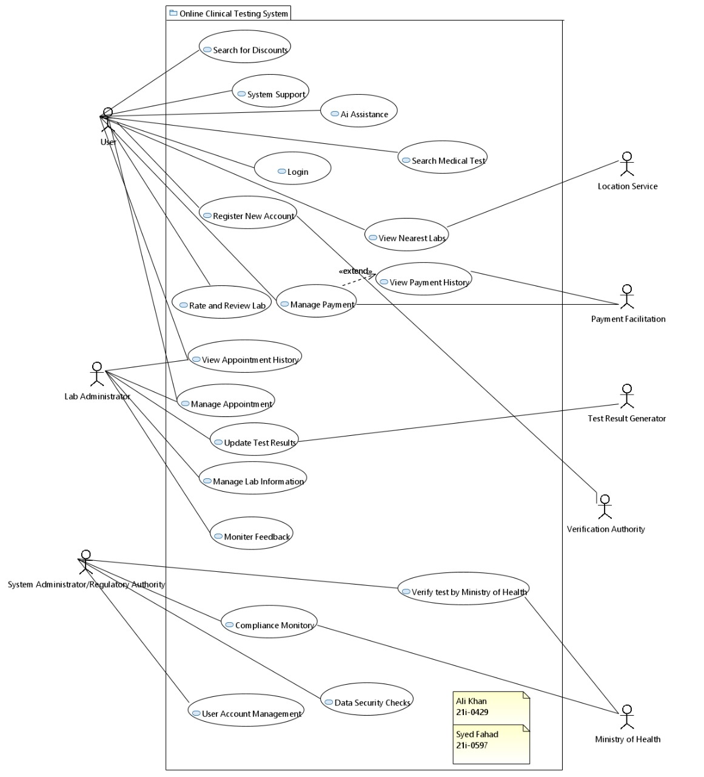

**Other Non-Functional Requirements:**

**Performance Requirement:**

**1. Response Time:**

The system should respond to user actions, such as appointment booking and result retrieval, within an acceptable time frame, aiming for response times of under 3 seconds for optimal user experience.

**2. System Availability:**

The system should maintain a high level of availability, with at least 99.9% uptime, ensuring continuous access to critical functionalities.

**3. Scalability:**

The system should be designed to handle an increasing number of users, appointments, and data volume. It should scale horizontally to accommodate growth without significant performance degradation.

**4. Concurrent Users:**

The system should support a large number of concurrent users, with the capacity to handle peak usage times, ensuring a smooth and responsive experience for all users.

**5. Data Throughput:**

The system should handle a high volume of data transactions efficiently, ensuring quick processing of appointment bookings, payments, and test result deliveries.

**6. AI Assistance Response Time:**

The AI assistance feature should provide quick and accurate responses to user queries, with a response time of under 2 seconds for an efficient user interaction.

**7. Security Performance:**

The system's security features, including data encryption and authentication processes, should add minimal overhead to the overall system performance.

**8. Payment Processing Time:**

The payment processing module should execute transactions swiftly, with minimal latency, ensuring a seamless and secure financial transaction experience.

**9. Compliance Check Frequency:**

The system should conduct compliance checks regularly, aiming for daily checks to identify and address any non-compliance issues promptly.

**10. System Monitoring Update Frequency:**

System logs and monitoring tools should update in real-time, providing administrators with up-to-date information on system activities and potential issues.

**11. Ministry of Health Verification Time:**

The system should facilitate the verification of medical tests with external regulatory authorities within a reasonable time frame, aiming for a verification process completed within 48 hours.

**Safety Requirement:**

**1. Data Confidentiality:**

The system must prioritize the confidentiality of patient data, ensuring that sensitive information is securely stored and accessed only by authorized personnel.

**2. Data Integrity:**

The system should implement measures to maintain the integrity of medical test results, preventing unauthorized modifications or tampering.

**3. Secure Payment Processing:**

Payment transactions must be conducted securely, following industry-standard encryption protocols to protect financial information from potential breaches.

**4. Access Control:**

Access to sensitive functionalities and data within the system must be restricted based on user roles, ensuring that only authorized individuals have access to specific information.

**5. Compliance with Regulations:**

The system must adhere to relevant healthcare regulations, data protection laws, and industry standards to ensure legal compliance and patient safety.

**6. AI Assistance Safeguards:**

AI assistance features should be programmed with safety measures to avoid providing incorrect or potentially harmful information to users.

**7. System Monitoring and Alerts:**

The system must incorporate robust monitoring tools to detect and alert administrators of any unusual or potentially unsafe activities promptly.

**8. Ministry of Health Verification Accuracy:**

Information submitted for the verification of medical tests with external regulatory authorities, such as the Ministry of Health, must be accurate and verifiable to ensure patient safety and regulatory compliance.

**9. Emergency Support:**

The system should have mechanisms in place to provide support and guidance in emergency situations, such as immediate access to critical test results or emergency contact information.

**10. Secure Communication:**

All communications between the system components, including user devices, servers, and external interfaces, should be encrypted to prevent unauthorized access or interception.

**Safety Requirement:**

**User Authentication:**

Implement secure user authentication mechanisms, such as multi-factor authentication, to ensure that only authorized users have access to the system.

**Access Control:**

Enforce role-based access control, limiting user access to specific functionalities and data based on their roles within the system.

**Data Encryption:**

Employ robust encryption protocols to protect sensitive data, including patient information, payment details, and medical test results, during transmission and storage.

**Audit Trail:**

Maintain detailed and secure audit trails, logging user activities and system events, to facilitate monitoring, analysis, and forensic investigation.

**Secure Payment Processing:**

Utilize industry-standard security measures for payment processing, ensuring the confidentiality and integrity of financial transactions.

**Incident Response Plan:**

Develop and implement an incident response plan to address security breaches promptly, minimizing the impact on the system and user data.

**Data Backup and Recovery:**

Implement regular data backup procedures and establish a robust data recovery plan to ensure data integrity and availability in the event of system failures or data loss in the data base.

**Secure APIs and Interfaces:**

Ensure that all APIs and external interfaces adhere to secure coding practices, validating input data, and preventing vulnerabilities.

**Password Policies:**

Enforce strong password policies, including complexity requirements and regular password updates, to enhance user account security.

**Data Segmentation:**

Implement data segmentation to ensure that different types of data are stored separately, reducing the risk of unauthorized access to sensitive information.

**Secure AI Assistance:**

Implement security measures in the AI assistance module to prevent exploitation or misuse, ensuring the integrity of information provided to users.

**Ministry of Health Compliance:**

Ensure that the system complies with security requirements outlined by regulatory authorities, such as the Ministry of Health, to maintain regulatory compliance.

**Secure System Configuration:**

Allow system administrators to configure settings securely, following best practices for system hardening and security configuration.

**Software Quality Attributes:**

**Reliability:**

The system should consistently perform its intended functions without failures, ensuring a reliable and trustworthy platform for users and healthcare providers.

**Usability:**

Provide an intuitive and user-friendly interface that allows users to easily navigate the system, book appointments, and access medical information without encountering usability challenges.

**Performance Efficiency:**

Optimize system performance to ensure fast response times, minimal latency, and efficient use of computing resources, especially during peak usage periods.

**Scalability:**

Design the system architecture to scale horizontally, accommodating a growing user base and increasing data volume without compromising performance.

**Maintainability:**

Develop the system with clean and modular code, well-documented features, and easy-to-understand architecture to facilitate ongoing maintenance and updates.

**Security:**

Implement robust security measures to protect user data, ensure secure payment processing, and prevent unauthorized access, ensuring the confidentiality and integrity of healthcare information.

**Interoperability:**

Design the system to seamlessly integrate with external systems, APIs, and healthcare databases to promote interoperability and information exchange.

**Availability:**

Maintain high system availability, minimizing downtime and ensuring users have continuous access to critical functionalities, even during maintenance activities.

**Adaptability:**

Build the system with the flexibility to adapt to changing healthcare regulations, technological advancements, and evolving user needs over time.

**Compliance:**

Ensure that the system complies with relevant healthcare regulations, data protection laws, and industry standards, demonstrating a commitment to legal and ethical standards.

**Accuracy:**

Guarantee the accuracy of medical test results and information provided by the system, preventing errors that could impact patient care and trust in the platform.

**Responsiveness:**

Design the system to respond promptly to user interactions, delivering real-time updates, notifications, and results to enhance user engagement and satisfaction.

**Resilience:**

Implement measures to withstand and recover from system failures, ensuring that critical functionalities remain available and data integrity is maintained.

**Consistency:**

Provide a consistent user experience across different modules and functionalities, promoting a cohesive and seamless interaction flow.

**Business Rule:**

**Appointment Scheduling:**

Patients must schedule appointments for medical tests through the online platform; walk-in appointments are not permitted.

**Lab Selection:**

Patients can choose a laboratory for their medical tests based on location, availability, and reputation.

**Payment Processing:**

Payments for medical tests must be made through the secure payment gateway provided by the system before the scheduled appointment.

**Results Access:**

Patients can access their medical test results securely through the online platform after authentication.

**Feedback and Reviews:**

Patients are encouraged to provide feedback and reviews about their experiences with specific labs and medical tests to contribute to system improvement.

**AI Assistance Guidelines:**

AI assistance should adhere to guidelines ensuring accurate, reliable, and non-misleading information is provided to users.

**Compliance Checks:**

Regular compliance checks must be conducted to ensure adherence to data security and healthcare regulations.

**Ministry of Health Verification:**

Medical tests must undergo verification by external regulatory authorities, such as the Ministry of Health, to ensure compliance with industry standards.

**User Account Management:**

System administrators are responsible for managing user accounts, including creation, updates, and deactivation.

**Emergency Support:**

The system should provide additional support and guidance in emergency situations, ensuring quick access to critical test results or emergency contact information.

**Password Policies:**

Users must adhere to strong password policies, including complexity requirements and regular updates.

**System Configuration:**

System administrators are responsible for configuring and modifying system settings, ensuring that the system operates within specified parameters.

**Data Segmentation:**

Different types of data, such as patient information and test results, should be stored separately to prevent unauthorized access.

**Security Patching:**

Regular security patches and updates must be applied to the system components to address known vulnerabilities.

**Operating Environment:**

**Server Infrastructure:**

The system will be hosted on dedicated eclipse and MySQL interfaces with sufficient computing resources to handle concurrent user interactions, database transactions as well.

**Operating System:**

The servers will run on a secure and reliable operating system, such as Linux or Windows Server, to provide a stable foundation for the system.

**Database Management System:**

The system will utilize a relational database management system (RDBMS) like MySQL.

**Programming Language:**

The system will be developed using a programming language such as Java, JavaFX, Swing, SQL ensuring flexibility and scalability.

**Compliance Tools:**

Tools and software for compliance monitoring and checks will be integrated into the system to ensure adherence to data security and healthcare regulations.

**External Interfaces:**

The system will have interfaces to connect with external systems, including healthcare databases, regulatory authorities, and third-party APIs for additional services.

**Development and Testing Tools:**

Development and testing will be carried out using industry-standard tools and frameworks, including version control systems, testing frameworks, and continuous integration tools.

**Backup and Recovery Solutions:**

Regular backup procedures and recovery solutions will be implemented to safeguard data integrity and provide resilience against data loss in the data bases.

**User Interfaces:**

**Login Interface:**

A secure login page where users, including patients, lab administrators, and system administrators, can enter their credentials to access the system.

**Registration Page:**

An intuitive registration form allowing new users to create accounts by providing necessary information, including personal details and contact information.

**Appointment Booking:**

An easy-to-use interface for patients to schedule appointments for medical tests, with options to select test types, preferred dates, and available labs etc.

**Lab Selection:**

A lab selection page where patients can view information about different labs, including location, availability, and user reviews, to make informed choices.

**Payment Processing:**

A secure payment gateway interface for users to enter payment details and complete transactions for appointment bookings

**Test Results Viewing:**

A dedicated section for patients to securely view and download their medical test results, with explanations and interpretations provided when applicable.

**Feedback and Reviews:**

A feedback form and review section where users can provide comments and ratings for labs and medical tests, contributing to the overall improvement of the system.

**AI Assistance Chatbot:**

An interactive chatbot interface that provides users with assistance, information, and guidance related to medical tests, appointments, and general queries.

**User Account Management (Administrator):**

An interface for system administrators to manage user accounts, including account creation, updates, and deactivation, with role-based access control.

**Compliance Monitoring Dashboard (Administrator):**

A monitoring dashboard for administrators to track compliance status, receive alerts, and conduct regular checks to ensure adherence to regulations.

**Appointment History:**

An interface displaying the history of past and upcoming appointments for patients, providing a comprehensive overview of their healthcare journey.

**Payment History:**

A page where users can review their payment history, including details of transactions related to appointment bookings and medical tests.

**Domain Model (papyrus):**

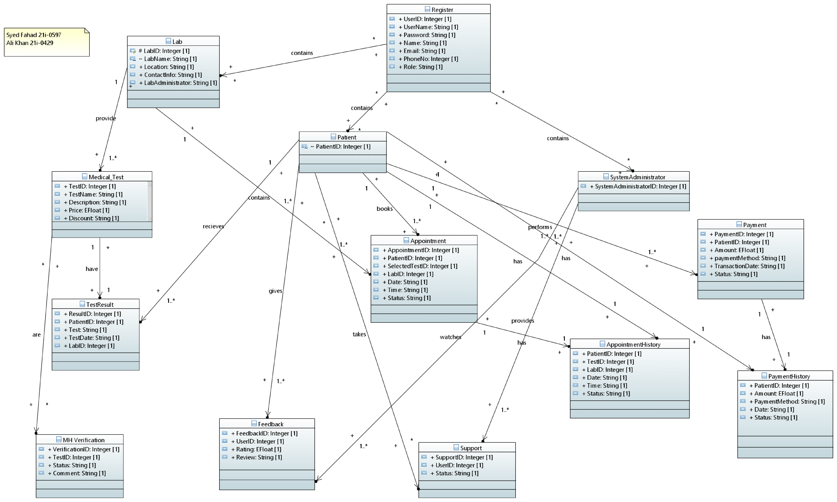

**Domain Model (other tool):**

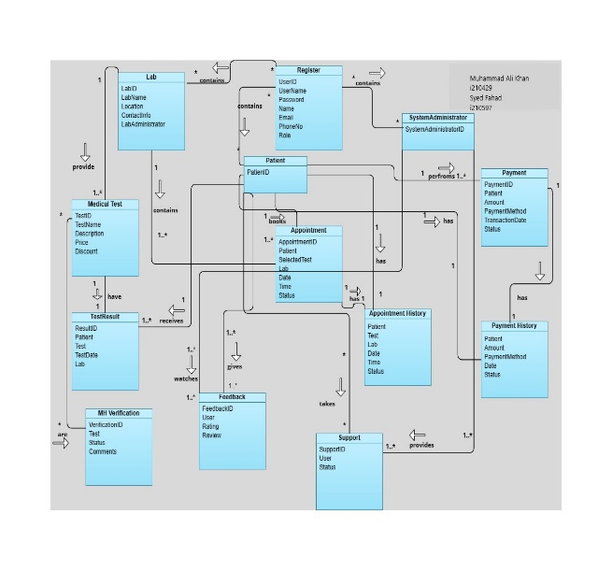

**System Sequence Diagrams:**

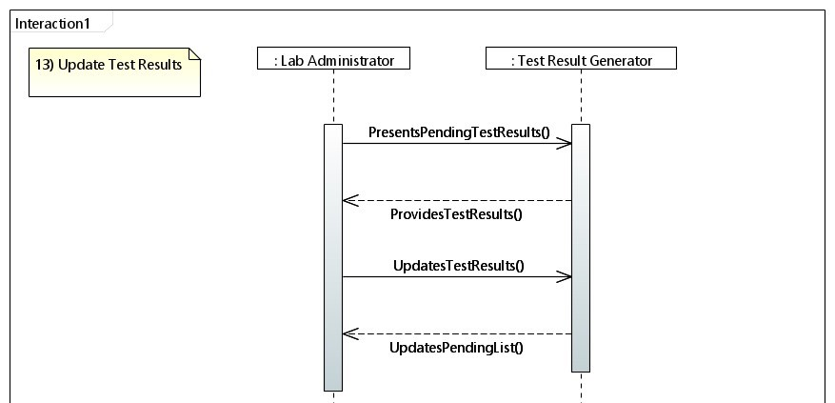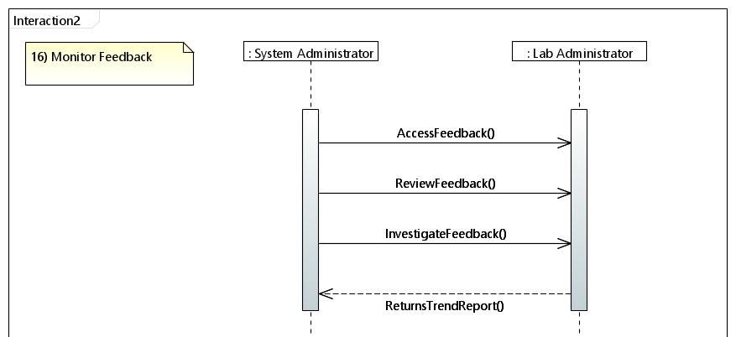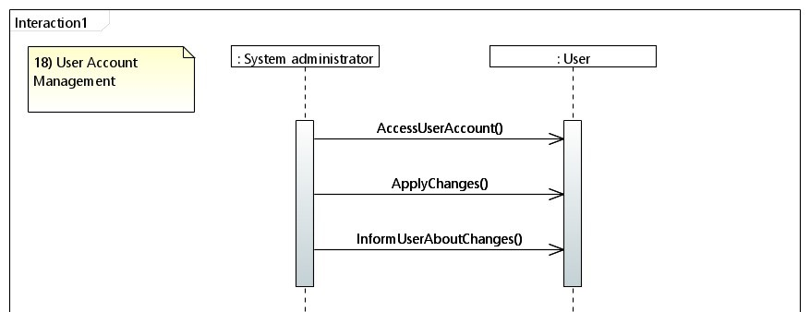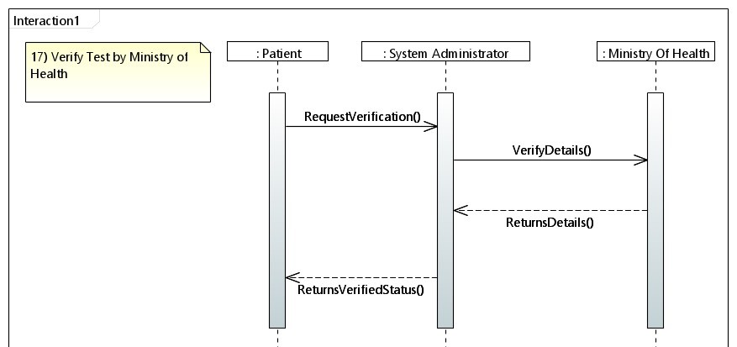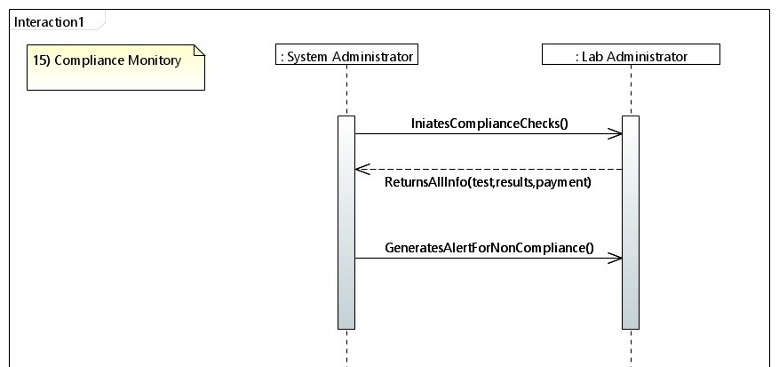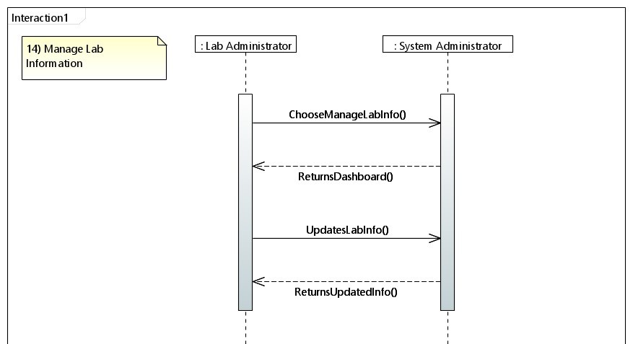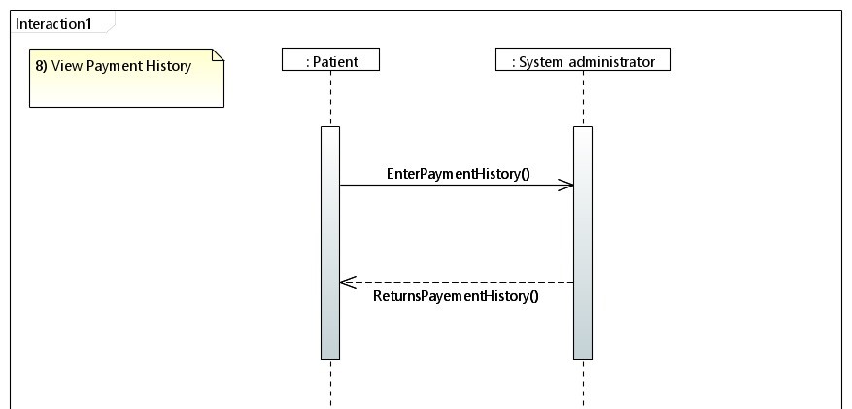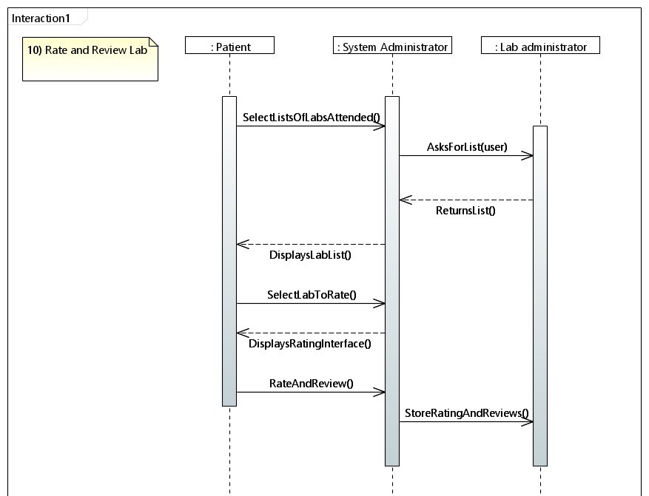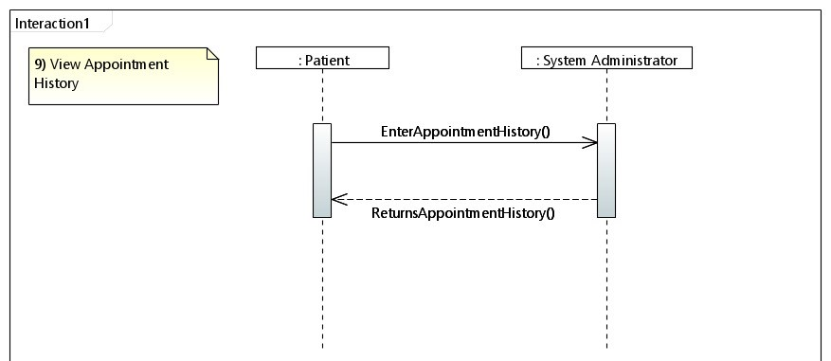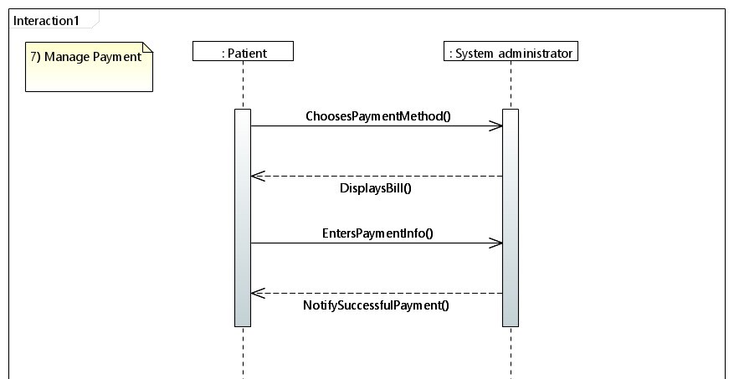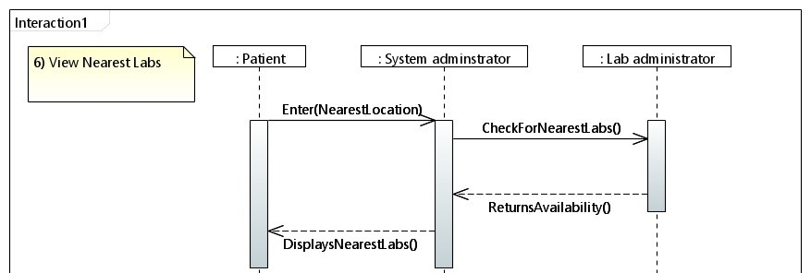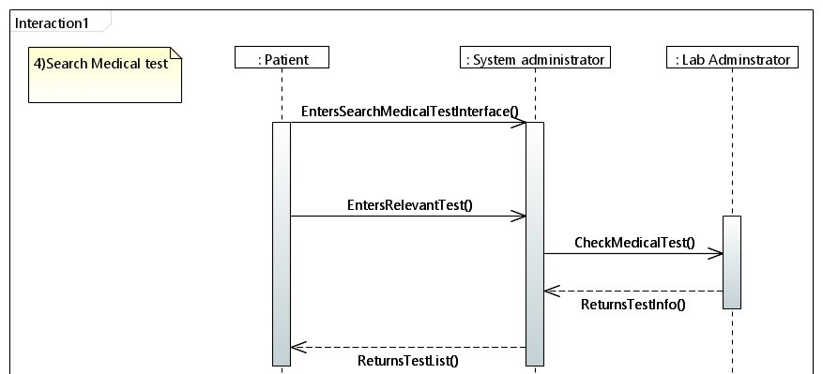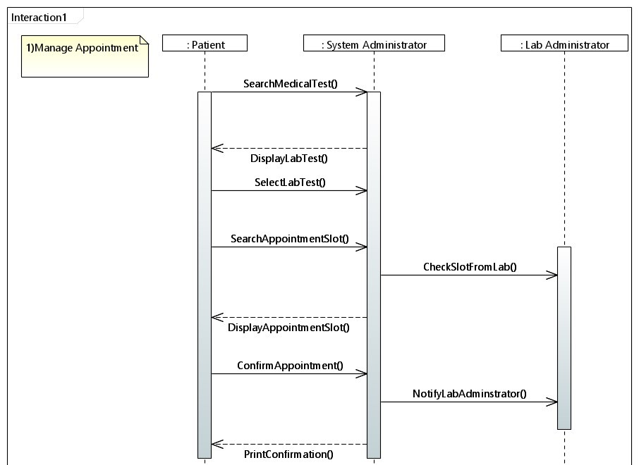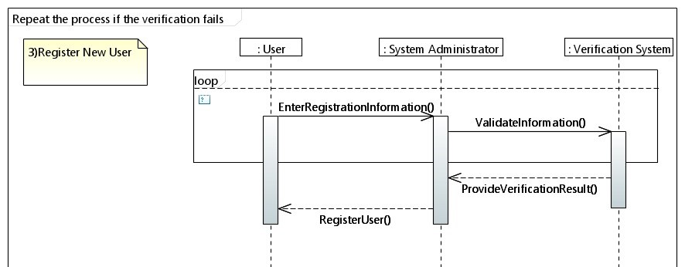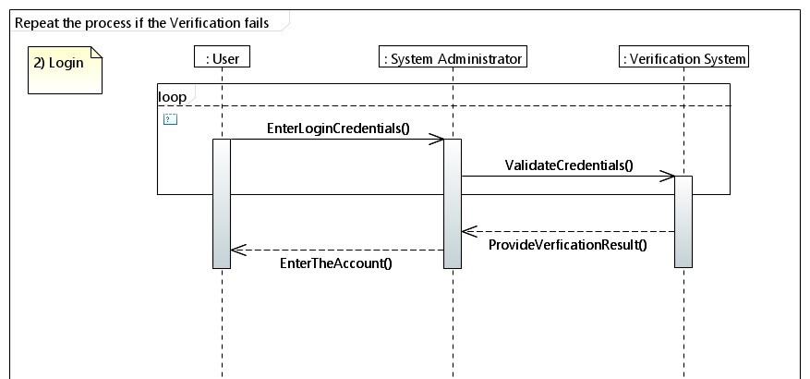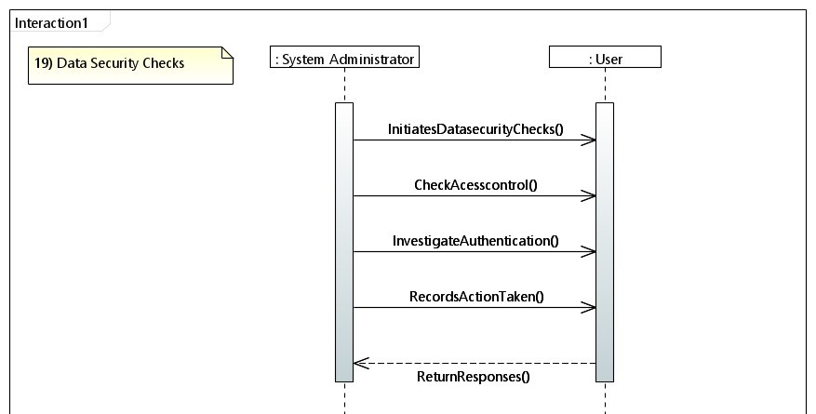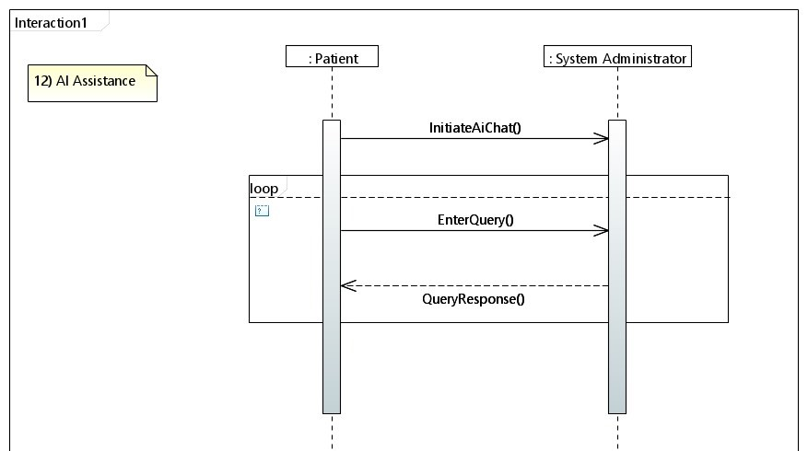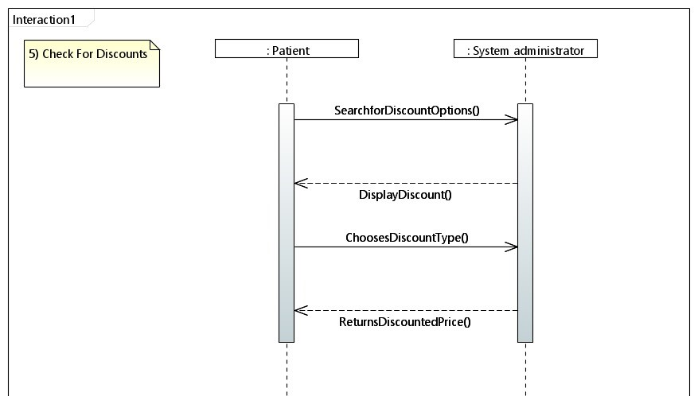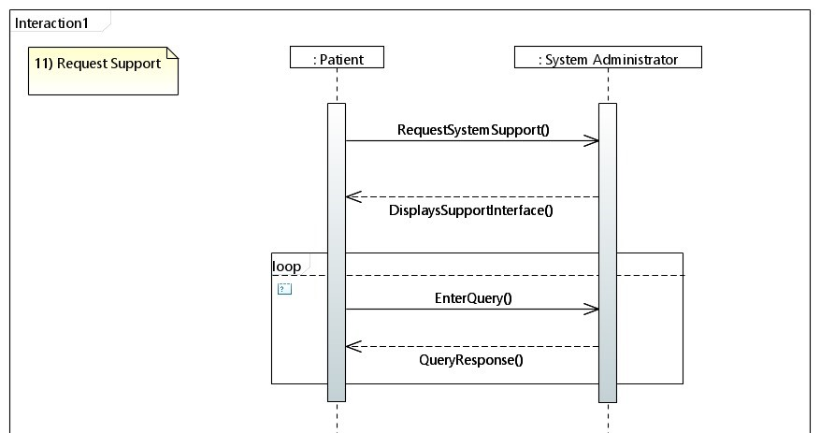

**Sequence Diagrams:**

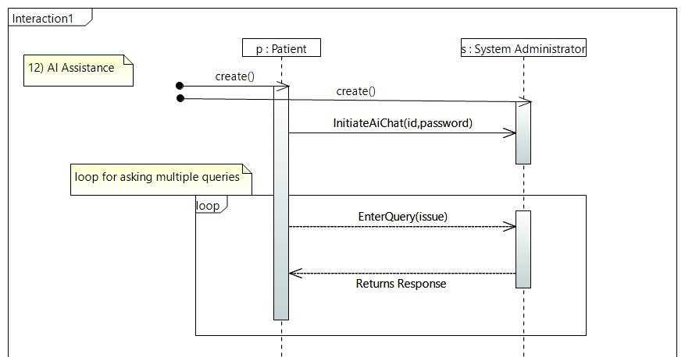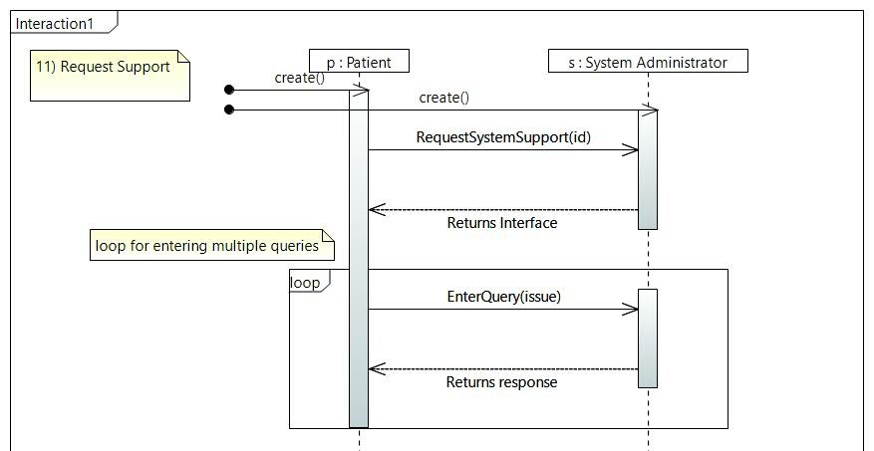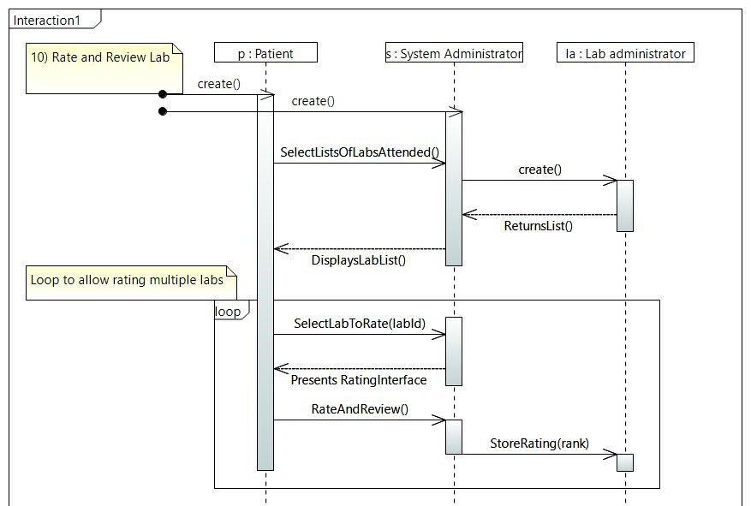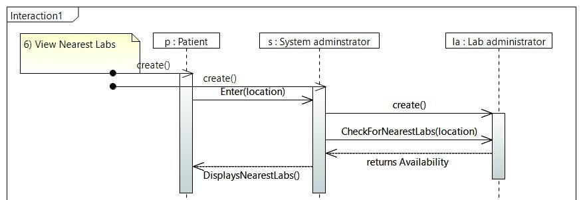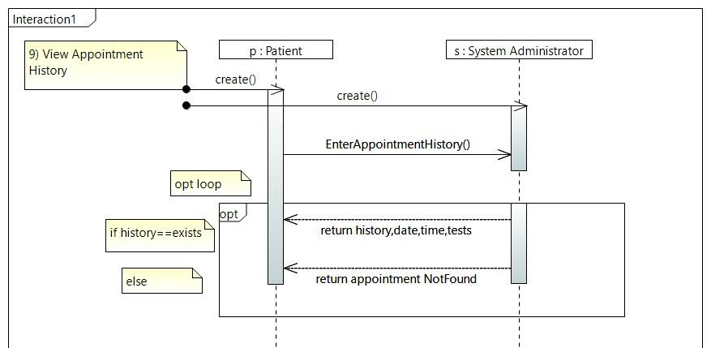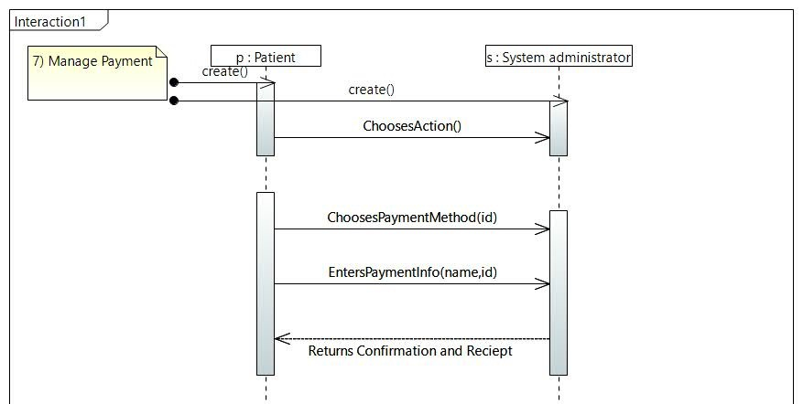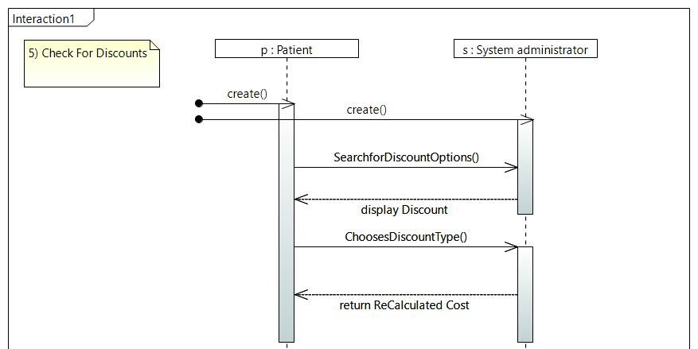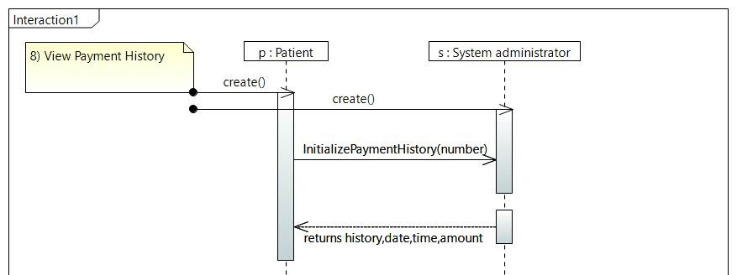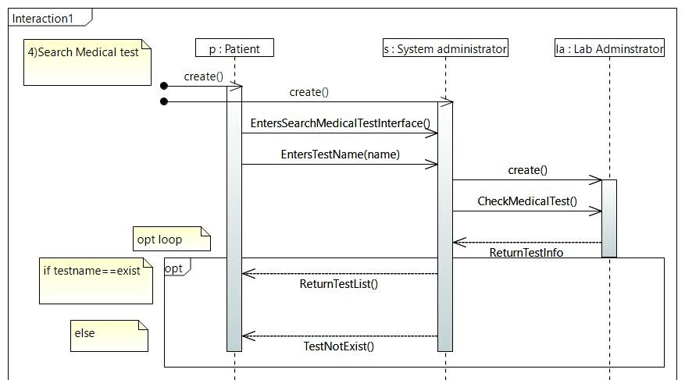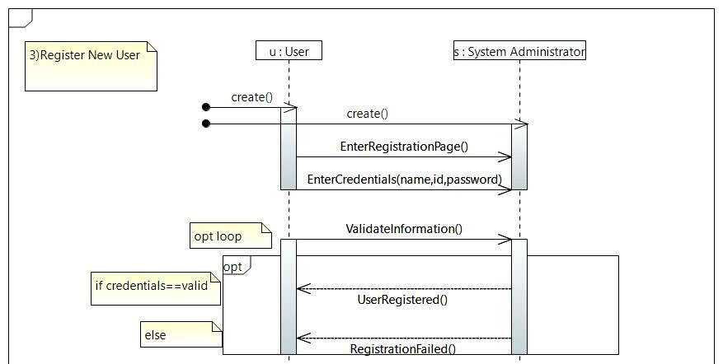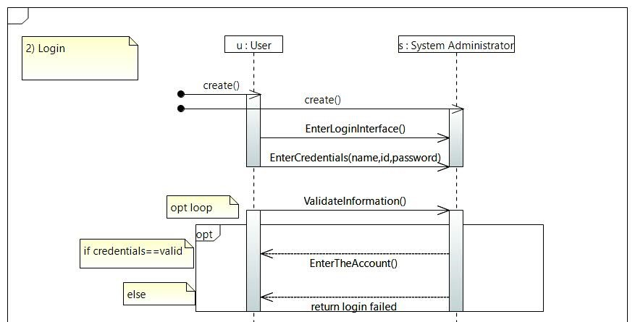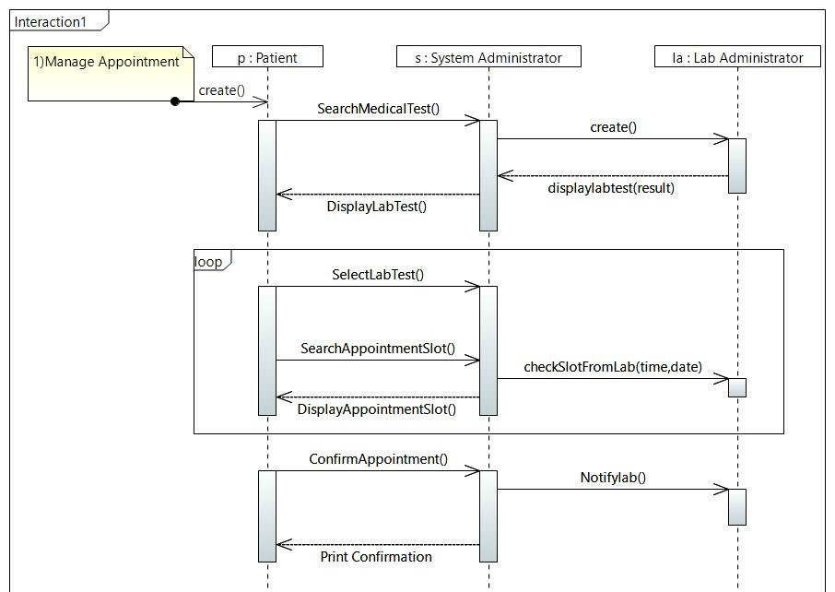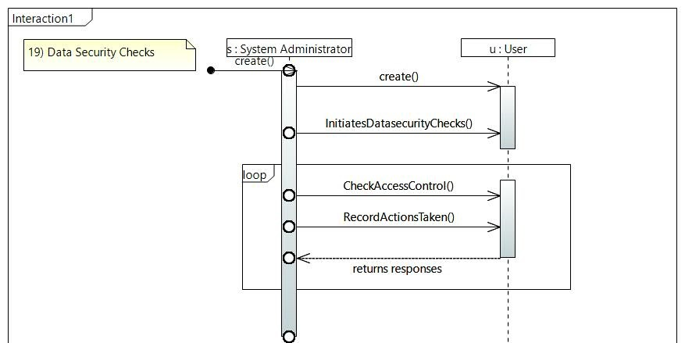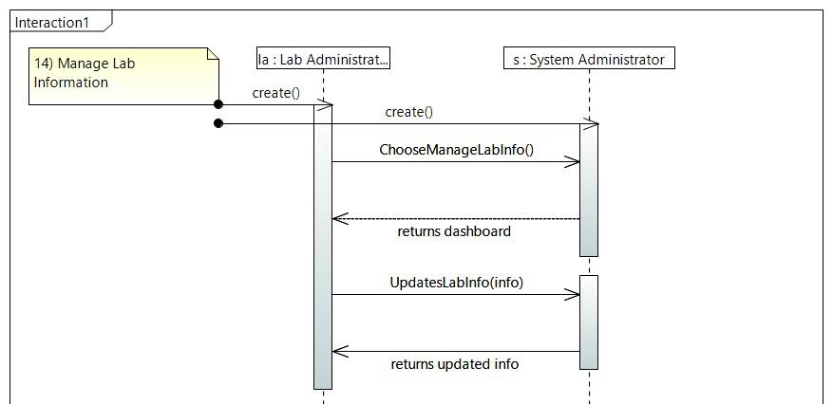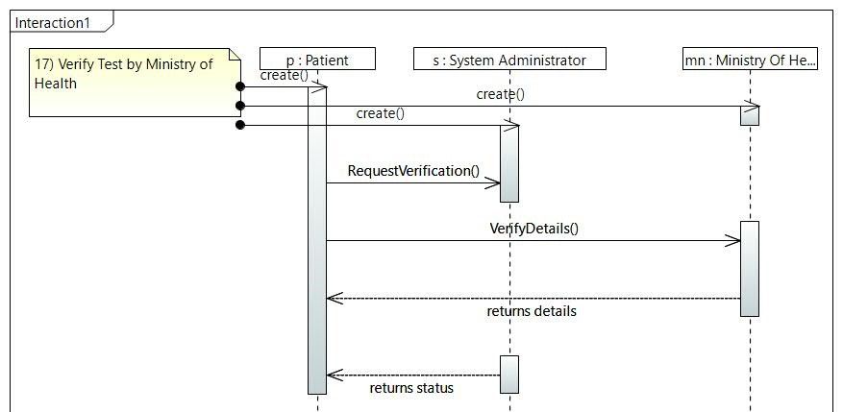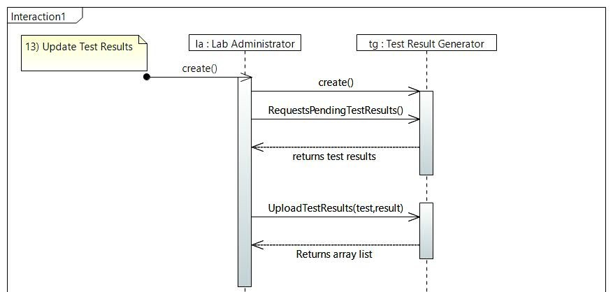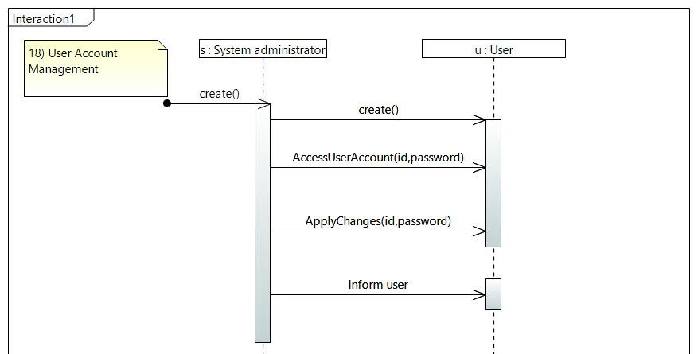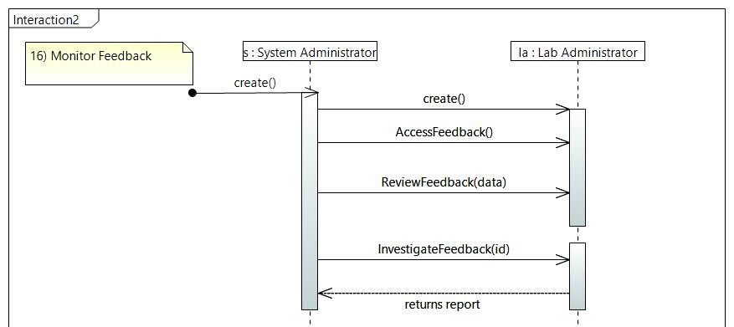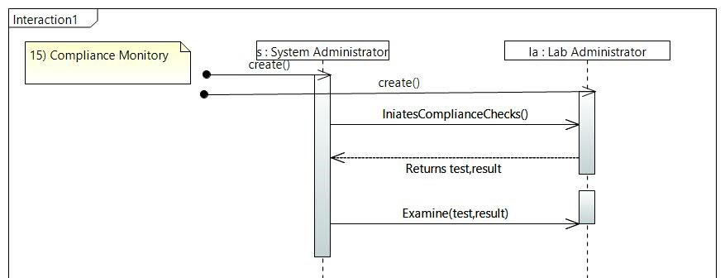

**Class Diagram (papyrus):**

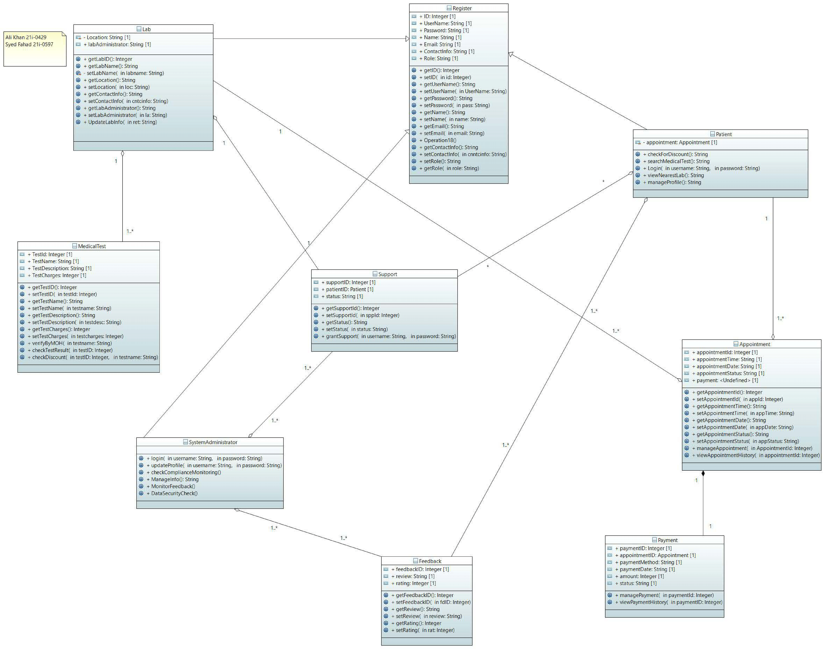

**Class Diagram (other tool):**

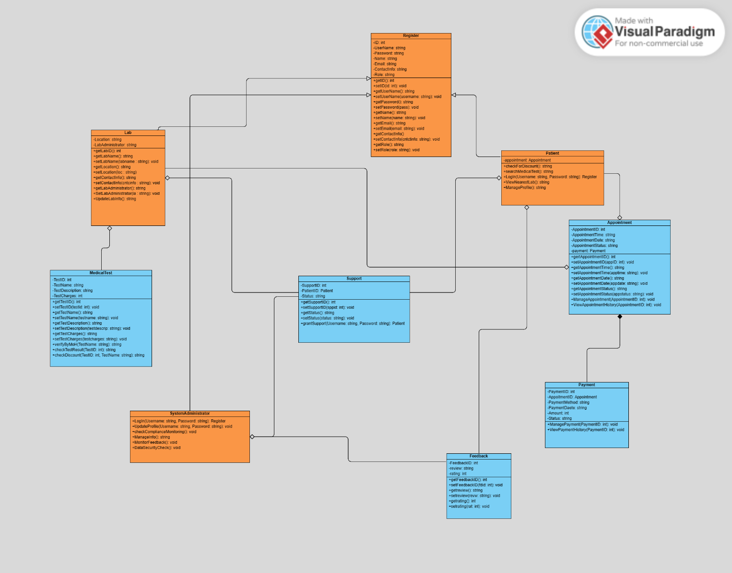

**Package Diagram:**

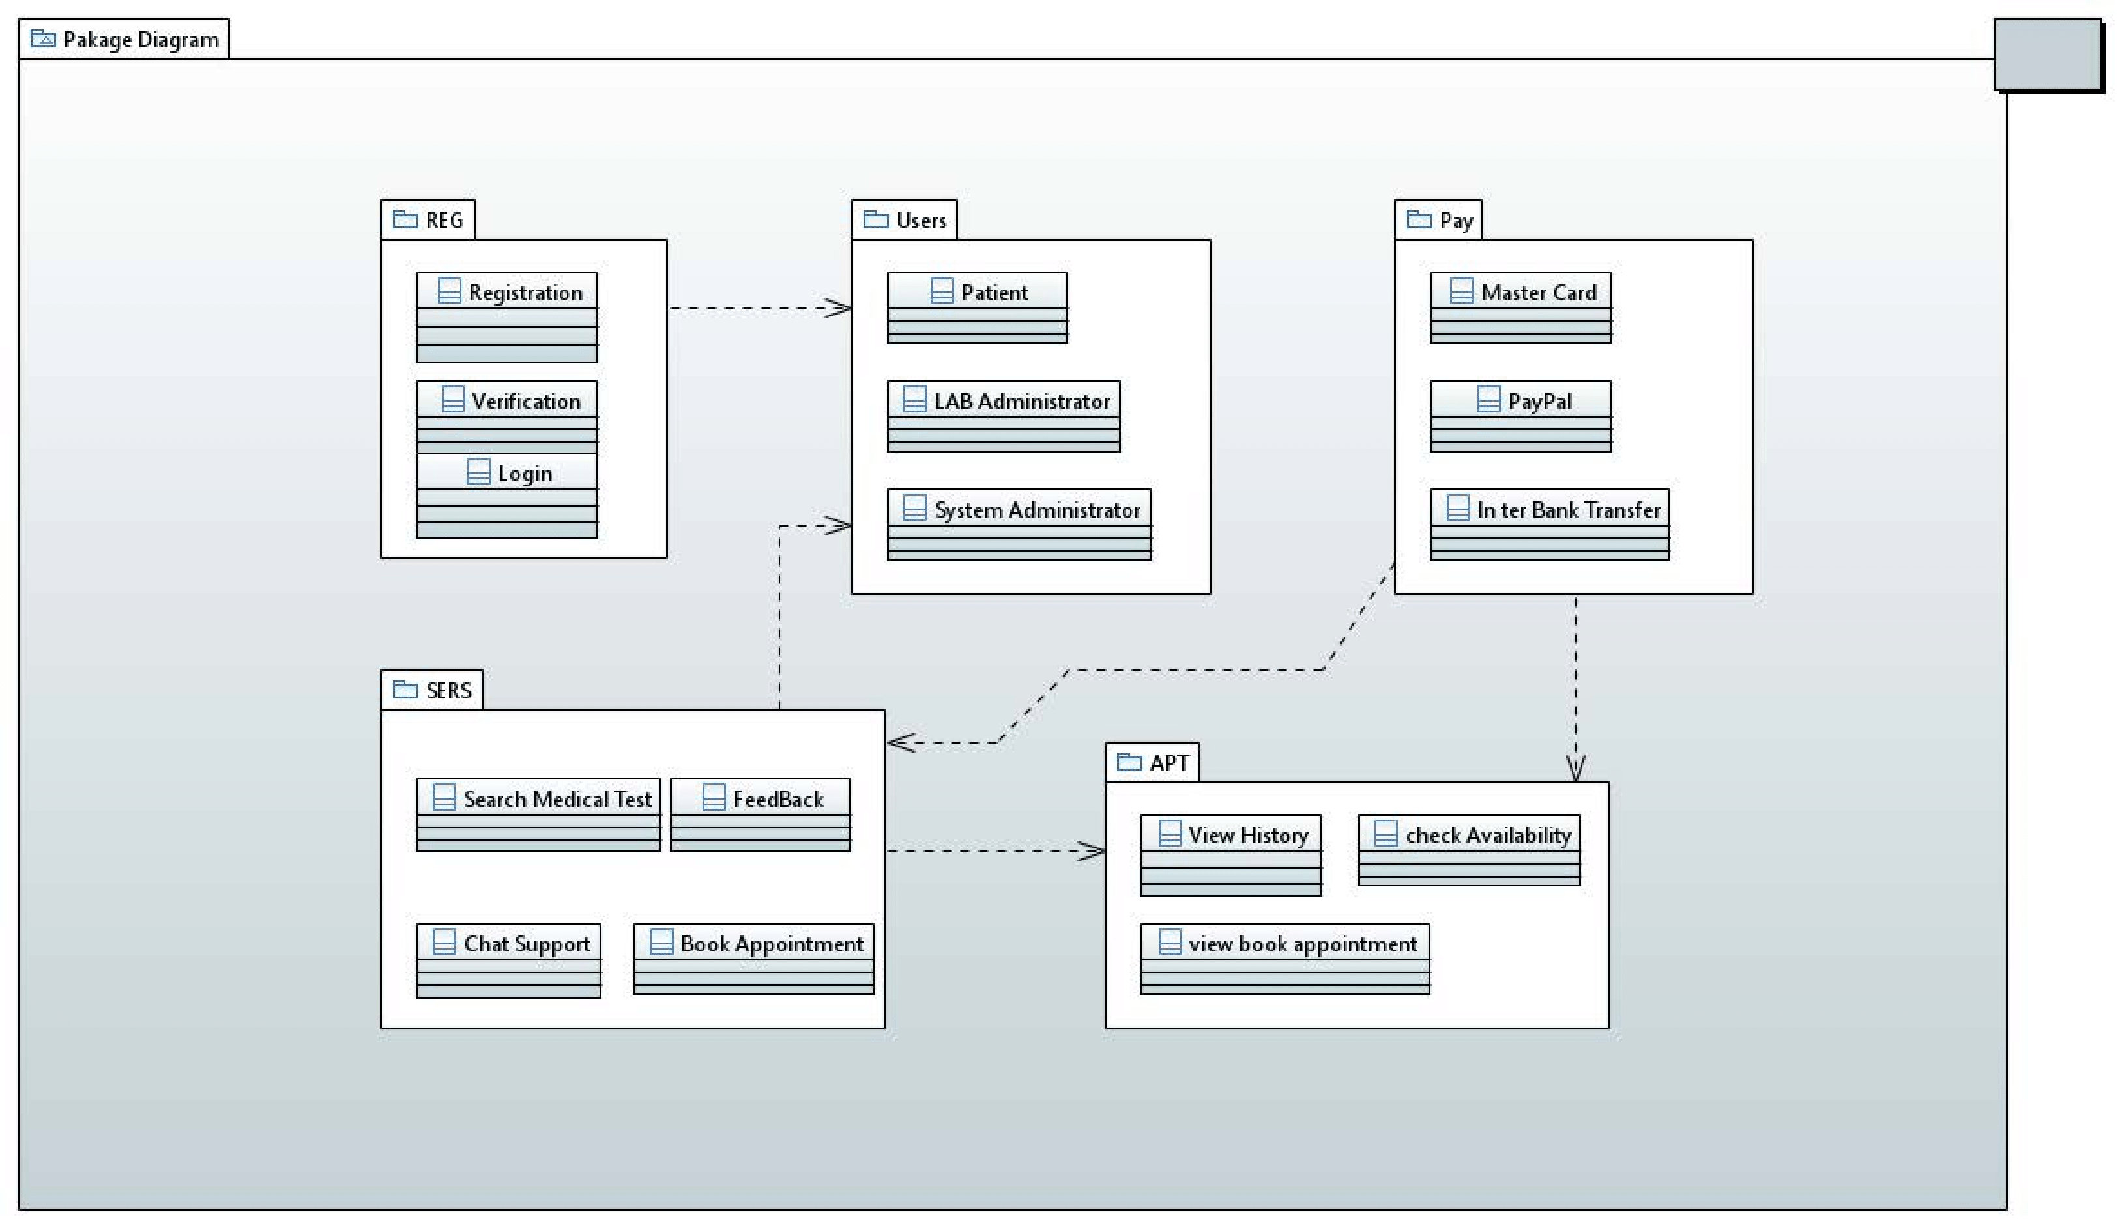

**Deployment Diagram:**

